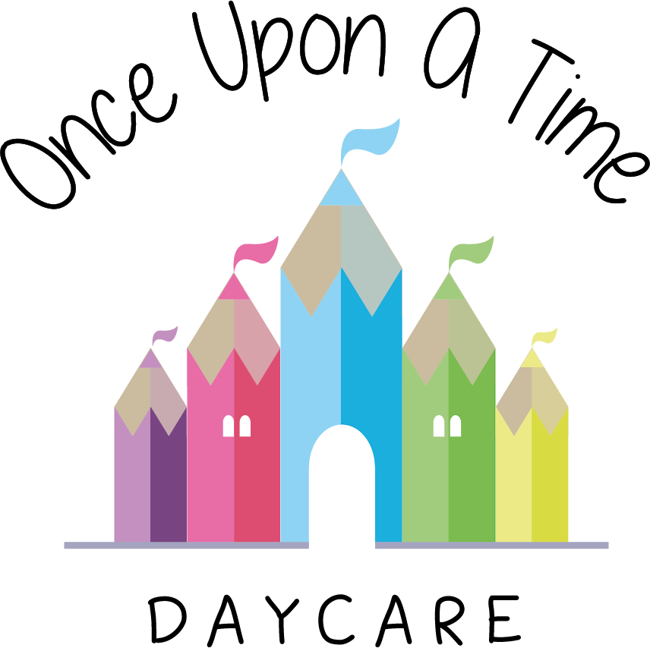

Overall Approach to Risk Assessment
7. Overall Approach to Risk Assessment

EYFS: 3.64

At Once Upon A Time Daycare we promote the safety of children, parents, staff and visitors by reviewing and reducing any risks.

Risk assessments
Risk assessments document the hazards/aspects of the environment that needs to be checked on a regular basis, who could be harmed, existing controls, the seriousness of the risk/injury, any further action needed to control the risk, who is responsible for what action, when/how often will the action be undertaken, and how this will be monitored and checked and by whom.

The nursery carries out written risk assessments regularly (at least annually). These are regularly reviewed and cover potential risks to children, staff and visitors at the nursery. When circumstances change in the nursery, e.g. a significant piece of equipment is introduced; we review our current risk assessment or conduct a new risk assessment dependent on the nature of this change.

All staff are trained in the risk assessment process to ensure understanding and compliance.

All outings away from the nursery are individually risk assessed and adequately staffed with paediatric first aid trained practitioners. For more details refer to the visits and outings policy.

Hints and tips
Please refer to the Health and Safety Executive’s ‘Five Steps to Risk Assessment’ www.hse.gov.uk/risk/fivesteps.htm for further support with the risk assessment process. The Five Steps to Risk Assessment publication and risk assessment templates can be downloaded from the Health and Safety Executive’s website at www.hse.gov.uk

Citation Plc can also offer further support with risk assessments at www.citation.co.uk

This policy was adopted on | Signed on behalf of the nursery | Date for review
1/6/18 | Rebecca Street (Manager) | 1/6/19
Date Reviewed 1/5//19 | Rebecca Street (Manger) | 1/5/20
Date Reviewed 1/3/20 | Rebecca Street (Manager) | 1/3/21
Date Reviewed 1/3/21 | Rebecca Street (Manager) | 1/3/22

