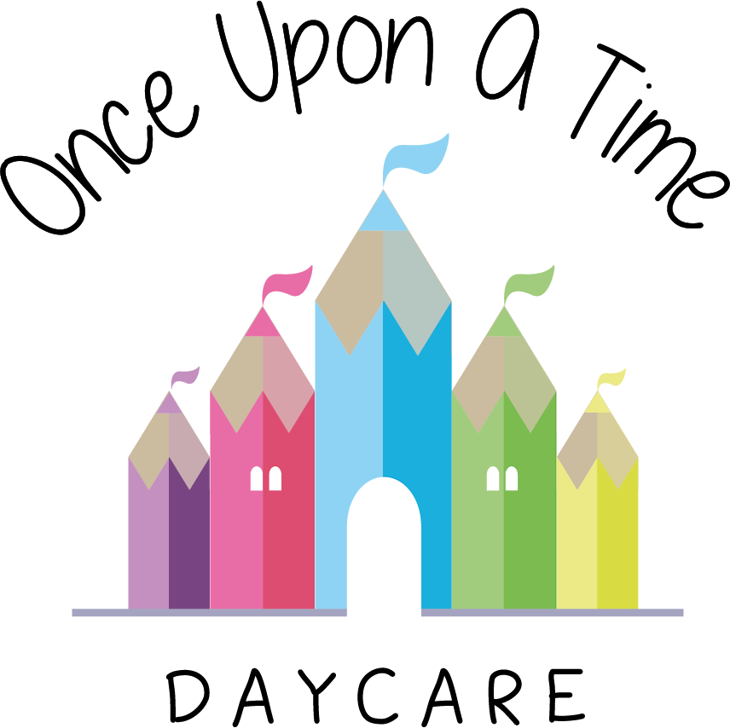

Biting
6b. Biting

At Once Upon A Time Daycare we follow a positive behaviour policy to promote positive behaviour at all times. However, we understand that children may use certain behaviours such as biting as part of their development. Biting is a common behaviour that some young children go through and can be triggered when they do not have the words to communicate their anger, frustration or need.

Our procedures
The nursery uses the following strategies to help prevent biting: sensory activities, biting rings, adequate resources and staff who recognise when children need more stimulation or quiet times. However, in the event of a child being bitten we use the following procedures. The most relevant staff member(s) will:
- Comfort any child who has been bitten and check for any visual injury. Administer any first aid where necessary. Complete an accident form and inform the parents via telephone if deemed appropriate. Continue to observe the bitten area for signs of infection. For confidentiality purposes and possible conflict we do not disclose the name of the child who has caused the bite to the parents
- Tell the child who has caused the bite in terms that they understand that biting (the behaviour and not the child) is unkind and show the child that it makes staff and the child who has been bitten sad. The child will be asked to say sorry if developmentally appropriate or helped to develop their empathy skills by giving the child who has been bitten a favourite book or comforter. Complete an incident form to share with the parents at the end of the child’s session
- If a child continues to bite, carry out observations to try to distinguish a cause, e.g. tiredness or frustration
- Arrange for a meeting with the child’s parents to develop strategies to prevent the biting behaviour. Parents will be reassured that it is part of a child’s development and not made to feel that it is their fault
- In the event of a bite breaking the skin and to reduce the risk of infection from bacteria, give prompt treatment to both the child who has bitten and the child who has been bitten.

If a child or member of staff sustains a bite wound where the skin has been severely broken arrange for urgent medical attention after initial first aid has been carried out.
In cases where a child may repeatedly bite and/or if they have a particular special educational need or disability that lends itself to increased biting, e.g. in some cases of autism where a child doesn’t have the communication skills, the nursery manager will carry out a risk assessment and may recommend immunisation with hepatitis B vaccine for all staff and children.

This policy was adopted on | Signed on behalf of the nursery | Date for review
1/6/18 | Rebecca Street (Manager) | 1/6/19
Date Reviewed 1/5//19 | Rebecca Street (Manger) | 1/5/20
Date Reviewed 1/3/20 | Rebecca Street (Manager) | 1/3/21
Date Reviewed 1/3/21 | Rebecca Street (Manager) | 1/3/22

