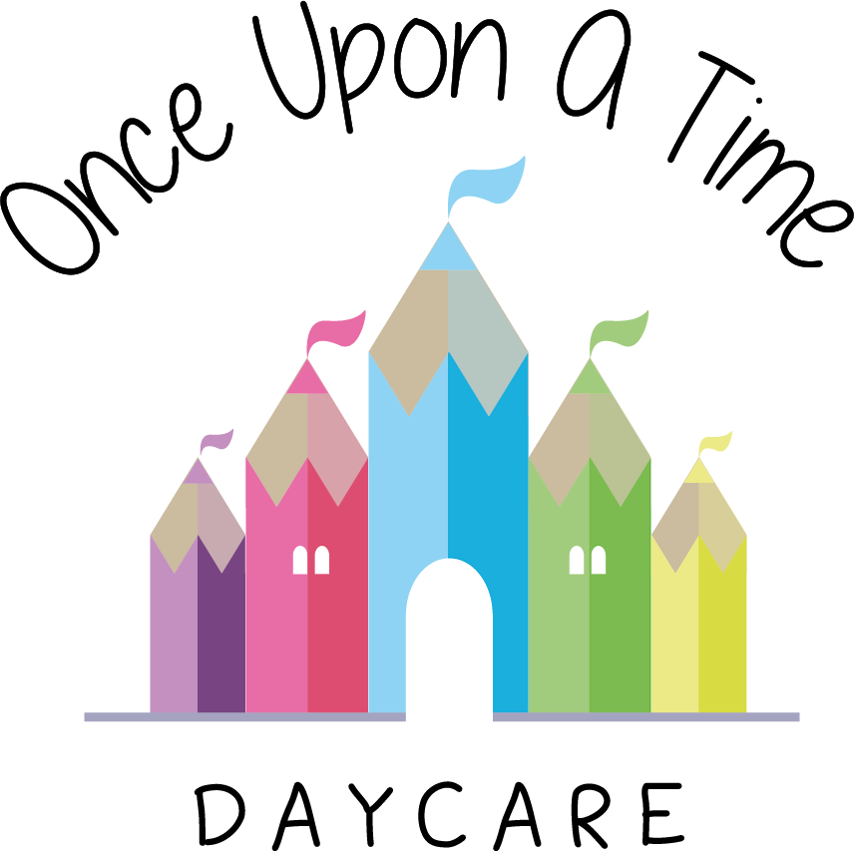

Nursery Operational Plan
59. Nursery Operational Plan

At Once Upon A Time Daycare we provide quality affordable childcare for the local community. Quality childcare brings benefits for the whole community, enabling parents to return to work and combine employment with family life and enabling employers to retain and recruit employees from the local community.

We want parents to feel confident about the quality of care that is provided for their child in order for them to have no concerns for their child’s health, welfare and early learning. To continuously develop our practice, we regularly complete a self-evaluation cycle where we publish our opinions about the quality of our childcare and an action plan to implement emerging good practice from the sector. We welcome parent’s opinions and contributions to the self evaluation process and actively seek feedback through questionnaires, parents’ evenings and informal discussion which is recorded.

In order for Once Upon A Time Daycare to run effectively and efficiently serve local community needs, it is important that we have an operational plan that is implemented, reviewed and revised on a regular basis. This plan is a blueprint for managing the nursery. It describes how the nursery is run and what type of service is provided. It describes the nursery service, the structure of the nursery, who is responsible and guidance on practices and procedures.

The plan is used by the nursery manager, staff, parents and outside agencies as a reference tool for general day-to-day practice and a tool against which to assess the quality of the service provided. We will review this policy on a regular basis, using reflective practice, and make and implement any necessary changes following a review.

Suggested contents to be kept in your operational plan:

Main index
- The Early Years Foundation Stage
- Assessment and Progress Checks
- Care Objectives
- Key Person
- Equal Opportunities and Inclusion

- Safeguarding and Child Protection
  - Emergency Contacts
  - Designated Person(s)

- Leadership and Management
  - Suitable People
  - Organisation Structure
  - Senior Management Contacts
  - Nursery Organisation Structure Chart
  - Staff Deployment
  - Training Analysis/Chart
  - Checklist for New Starters

- Health and Medicines
  - Names of the Staff who are Paediatric First Aid Trained
  - Contingency Plans
  - Accident and Medication Procedures

- Managing Behaviour
  - Policy and Procedure

- Safety and Suitability of Premises, Environment and Equipment
  - Emergency Evacuation Procedures
  - Emergency Locations
  - Policy and Procedure Documentation
  - Health and Safety Documentation
  - Daily Operations Statement
  - Risk Assessments
  - Outings

- Information and Records
  - Registration Details for Child
  - Occupancy and Daily Records
  - Parent Pack
  - Complaints and Compliments

- Business planning
  - Mission and Vision Statement
  - Inspection Report
  - Important Information
  - Nursery Plans
  - Nursery Leaflet.

This policy was adopted on | Signed on behalf of the nursery | Date for review
1/6/18 | Rebecca Street (Manager) | 1/6/19
Date Reviewed 1/5//19 | Rebecca Street (Manger) | 1/5/20
Date Reviewed 1/3/20 | Rebecca Street (Manager) | 1/3/21
Date Reviewed 1/3/21 | Rebecca Street (Manager) | 1/3/22

