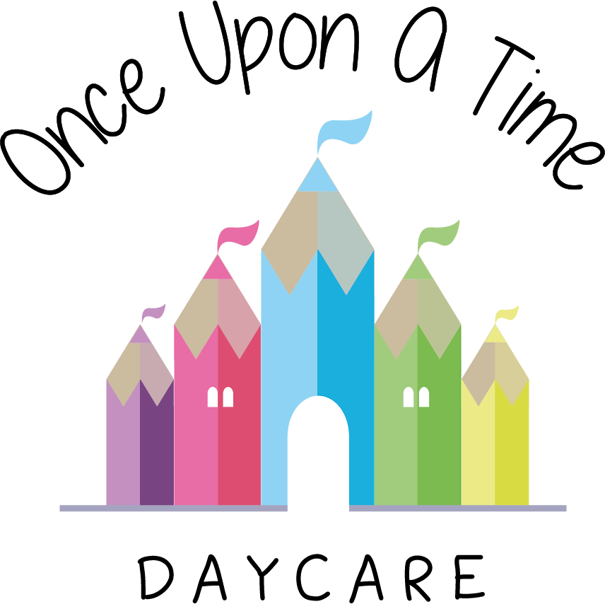

Arrivals and Departures
58. Arrivals and Departures

EYFS:3.7, 3.62

At Once Upon A Time Daycare we give a warm welcome to every child and family on their arrival.

Parents are requested to pass the care of their child to a specific member of staff who will ensure his/her safety (this is usually a child’s key person). The staff member receiving the child immediately records his/her arrival in the daily attendance register. The staff member also records any specific information provided by the parents, including the child’s interests, experiences and observations from home.

If the parent requests the child is given medicine during the day the staff member must ensure that the medication procedure is followed.

If the child is to be collected someone who is not the parent at the end of the session, there is an agreed procedure that must be followed to identify the designated person. A password is required for the designated adult. Parents are informed about these arrangements and reminded about them regularly.

The child’s key person or other nominated staff member must plan the departure of the child. This should include opportunities to discuss the child’s day with the parent, e.g. meals, sleep time, activities, interests, progress and friendships. The parent should be told about any accidents or incidents and the appropriate records must be signed by the parent before departure. Where applicable, all medicines should be recovered from the medicine box/fridge after the parent has arrived and handed to him/her personally. The medication policy is to be followed regarding parental signature.

The nursery will not release a child to anyone other than the known parent unless an agreement has been made at the time of arrival. In the case of any emergency such as a parent being delayed and arranging for a designated adult to collect a child, the parent should inform the designated person of the agreed procedure and contact the nursery about the arrangements as soon as possible. If in any doubt the nursery will check the person’s identity by ringing the child’s parent or their emergency contact number (please refer to the late collection policy).

On departure, the staff member releasing the child must mark the child register immediately marked to show that the child has left the premises.

Adults arriving under the influence of alcohol or drugs
Please refer to the alcohol and substance misuse policy.

Arrivals and departures of visitors
For arrivals and departures of visitors the nursery requires appropriate records to be completed on entry and exit e.g. in the visitors’ book. Please refer to supervision of visitor’s policy for further information.

This policy was adopted on | Signed on behalf of the nursery | Date for review
1/6/18 | Rebecca Street (Manager) | 1/6/19
Date Reviewed 1/5//19 | Rebecca Street (Manger) | 1/5/20
Date Reviewed 1/3/20 | Rebecca Street (Manager) | 1/3/21
Date Reviewed 1/3/21 | Rebecca Street (Manager) | 1/3/22
*Due to Covid-19 parents are unable to enter the building in line with our Covid-19 risk assessment. Each room also has a allocated door which they use to ensure we are minimizing contact and adhering to social distancing. (please see our Covid-19 risk assessment which is a separate document)

