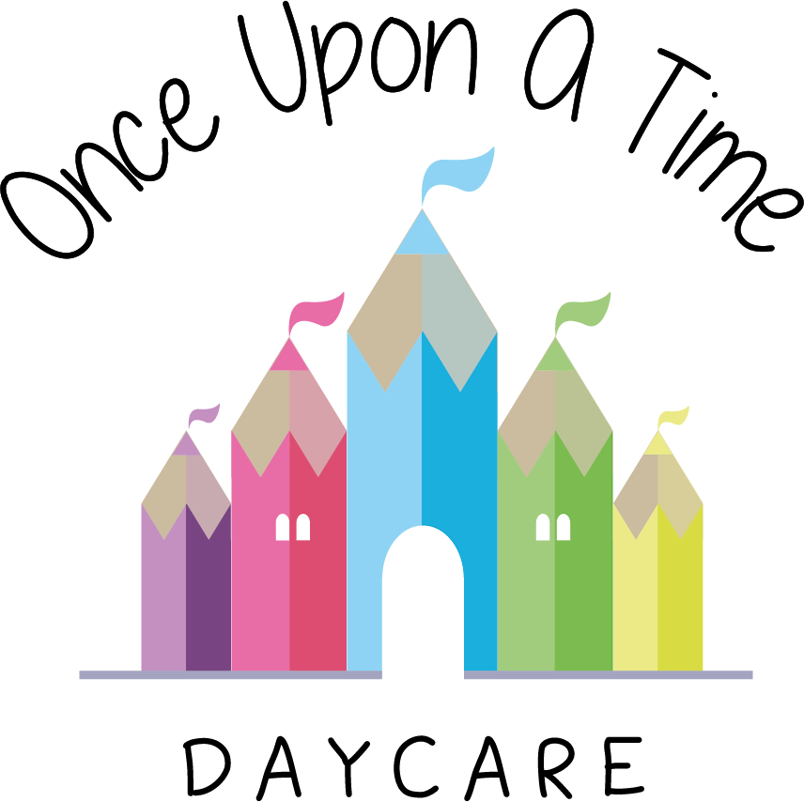

Conflict Resolution with Parents who may be Challenging
54. Conflict Resolution with Parents who may be Challenging

At Once Upon A Time Daycare we believe that we have a strong partnership with our parents and an open door policy to discuss any matters arising (if applicable).

In the unlikely event that a parent starts to act in an aggressive or abusive way at the nursery, our policy is to:
- Direct the parent away from the children and into a private area such as the office (where appropriate)
- Ensure that a second member of staff is in attendance, where possible, whilst continuing to ensure the safe supervision of the children
- Act in a calm and professional way, ask the parent to calm down and make it clear that we do not tolerate aggressive or abusive language or behaviour
- Contact the police if the behaviour escalates
- Once the parent calms down, the member of staff will then listen to their concerns and respond appropriately
- An incident form will be completed detailing the time, reason and action taken
- Management will provide any support and reassurance that staff may need following the experience, and seek further support where necessary
- Management will also signpost parents to further support where applicable
- Staff will protect the privacy of the children in our care and ensure that information regarding the incident is kept confidentially.

This policy was adopted on | Signed on behalf of the nursery | Date for review
1/6/18 | Rebecca Street (Manager) | 1/6/19
Date Reviewed 1/5//19 | Rebecca Street (Manger) | 1/5/20
Date Reviewed 1/3/20 | Rebecca Street (Manager) | 1/3/21
Date Reviewed 1/3/21 | Rebecca Street (Manager) | 1/3/22

