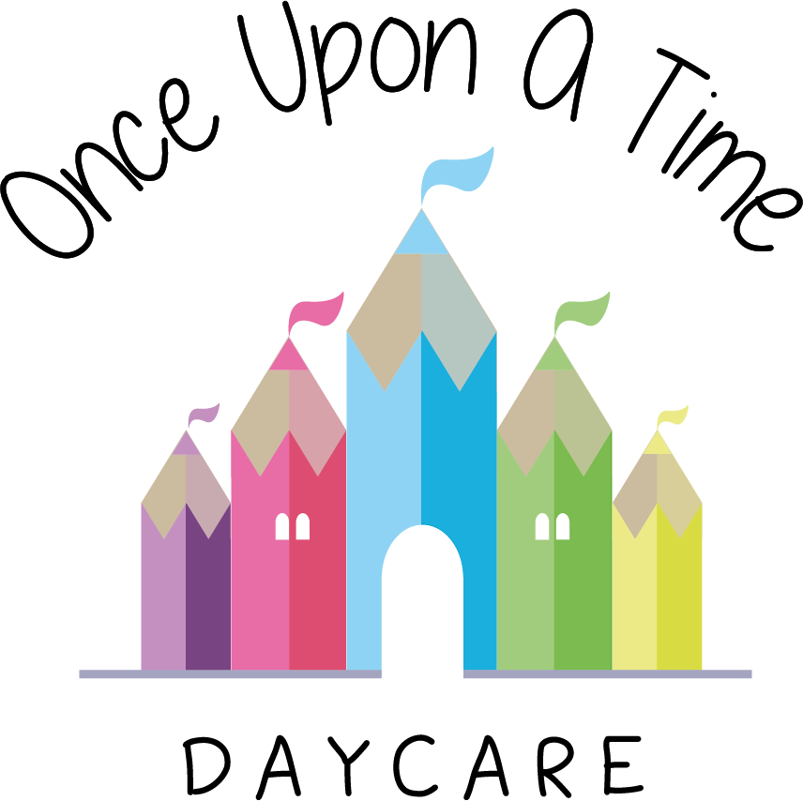

Parents and Carers as Partners
53. Parents and Carers as Partners

EYFS: 1.10, 3.27, 3.72, 3.73

At Once Upon A Time Daycare we believe that parents and staff need to work together in a close partnership in order for children to receive the quality of care and early learning to meet their individual needs. We welcome parents as partners and support a two-way sharing of information that helps establish trust and understanding. We are committed to supporting parents in an open and sensitive manner to include them as an integral part of the care and early learning team within the nursery.

The key person system supports engagement with all parents and will use strategies to ensure that all parents can contribute to their child’s learning and development. Parents contribute to initial assessments of children’s starting points on entry and they are kept well informed about their children’s progress. Parents are encouraged to support and share information about their children’s learning and development at home. The key person system ensures all practitioners use effective, targeted strategies and interventions to support learning that match most children’s individual needs.

Our policy is to:
- Recognise and support parents as their child’s first and most important educators and to welcome them into the life of the nursery
- Generate confidence and encourage parents to trust their own instincts and judgement regarding their own child
- Welcome all parents into the nursery at any time and provide an area where parents can speak confidentially with us as required
- Welcome nursing mothers. The nursery will make available a private area whenever needed to offer space and privacy to nursing mothers
- Ensure nursery documentation and communications are provided in different formats to suit each parent’s needs, e.g. Braille, multi-lingual, electronic communications
- Ensure that all parents are aware of the nursery’s policies and procedures. A detailed parent prospectus will be provided and our full policy documents will be available to parents at all times on the nursery website
- Maintain regular contact with parents to help us to build a secure and beneficial working relationship for their children
- Support parents in their own continuing education and personal development including helping them to develop their parenting skills and inform them of relevant conferences, workshops and training
- Create opportunities for parents to talk to other adults in a secure and supportive environment through such activities as open days, parents’ evenings and a parents’ forum
- Inform parents about the range and type of activities and experiences provided for children, the daily routines of the setting, the types of food and drinks provided for children and events through *regularly distributed newsletters/*the nursery website
- Operate a key person system to enable parents to establish a close working relationship with a named practitioner and to support two-way information sharing about each child’s individual needs both in nursery and at home. Parents are given the name of the key person of their child and their role when the child starts
- Inform parents on a regular basis about their child’s progress and involve them in shared record keeping. Parents’ evenings will be held at least twice a year. The nursery will consult with parents about the times of meetings to avoid excluding anyone
- Actively encourage parents to contribute to children’s learning through sharing observations, interests and experiences from home. This may be verbally, sharing photographs or in written form
- Agree the best communication method with parents e.g. email, face-to-face, telephone and share information about the child’s day, e.g. food eaten, activities, sleep times etc.
- Consider and discuss all suggestions from parents concerning the care and early learning of their child and nursery operation
- Provide opportunities and support for all parents to contribute their own skills, knowledge and interests to the activities of the nursery including signposting to relevant services, agencies and training opportunities
- Inform all parents of the systems for registering queries, compliments, complaints or suggestions, and to check that these systems are understood by parents
- Make sure all parents have access to our written complaints procedure
- Share information about the Early Years Foundation Stage, young children's learning in the nursery, how parents can further support learning at home and where they can access further information
- Provide a written contract between the parent(s) and the nursery regarding conditions of acceptance and arrangements for payment
- Respect the family’s religious and cultural backgrounds and beliefs and accommodate any special requirements wherever possible and practical to do so
- Inform parents how the nursery supports children with special educational needs and disabilities
- Find out the needs and expectations of parents. We will do this through regular feedback via questionnaires, suggestion system and encouraging parents to review working practices. We will evaluate any responses and publish these for parents with an action plan to inform future, policy and staff development.

This policy was adopted on | Signed on behalf of the nursery | Date for review
1/6/18 | Rebecca Street (Manager) | 1/6/19
Date Reviewed 1/5//19 | Rebecca Street (Manger) | 1/5/20
Date Reviewed 1/3/20 | Rebecca Street (Manager) | 1/3/21
Date Reviewed 1/3/21 | Rebecca Street (Manager) | 1/3/22

