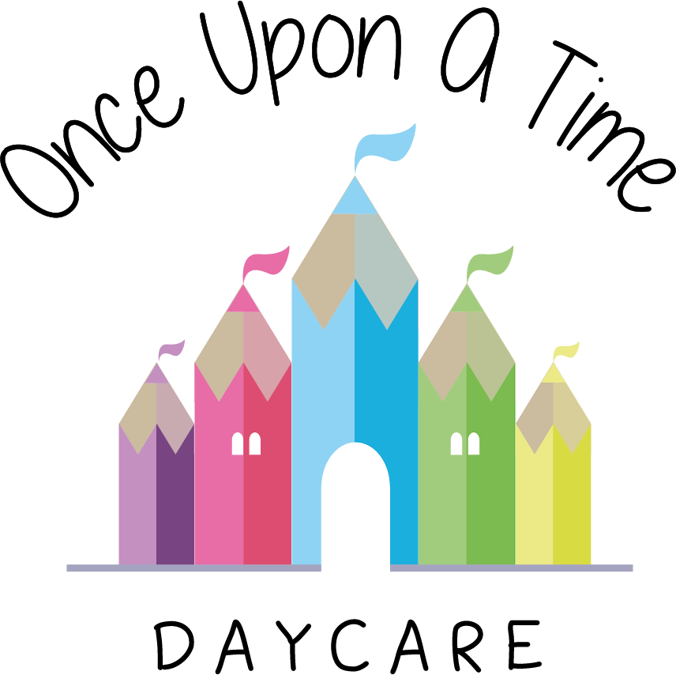

Medication
5. Medication

EYFS: 3.19, 3.44, 3.45, 3.46
At Once Upon A Time Daycare we promote the good health of children attending nursery and take necessary steps to prevent the spread of infection (see sickness and illness policy). If a child requires medicine we will obtain information about the child’s needs for this, and will ensure this information is kept up to date.

We follow strict guidelines when dealing with medication of any kind in the nursery and these are set out below.

Medication prescribed by a doctor, dentist, nurse or pharmacist
(Medicines containing aspirin will only be given if prescribed by a doctor)
- Prescription medicine will only be given when prescribed by the above and for the person named on the bottle for the dosage stated
- Medicines must be in their original containers with their instructions printed in English
- Those with parental responsibility for any child requiring prescription medication should hand over the medication to the most appropriate member of staff who will then note the details of the administration on the appropriate form and another member of staff will check these details
- Those with parental responsibility must give prior written permission for the administration of each and every medication. However, we will accept written permission once for a whole course of medication or for the ongoing use of a particular medication under the following circumstances:
- The written permission is only acceptable for that brand name of medication and cannot be used for similar types of medication, e.g. if the course of antibiotics changes, a new form will need to be completed
- The dosage on the written permission is the only dosage that will be administered. We will not give a different dose unless a new form is completed
- Parents must notify us IMMEDIATELY if the child’s circumstances change, e.g. a dose has been given at home, or a change in strength/dose needs to be given.
- The nursery will not administer a dosage that exceeds the recommended dose on the instructions unless accompanied by written instructions from a relevant health professional such as a letter from a doctor or dentist
- The parent must be asked when the child has last been given the medication before coming to nursery; and the staff member must record this information on the medication form. Similarly, when the child is picked up, the parent or guardian must be given precise details of the times and dosage given throughout the day. The parent’s signature must be obtained at both times
- At the time of administering the medicine, a senior member of staff will ask the child to take the medicine or offer it in a manner acceptable to the child at the prescribed time and in the prescribed form. (It is important to note that staff working with children are not legally obliged to administer medication)
- If the child refuses to take the appropriate medication, then a note will be made on the form
- Where medication is “essential” or may have side effects, discussion with the parent will take place to establish the appropriate response.

Non-prescription medication (these will not usually be administrated)
- The nursery will not administer any non-prescription medication containing aspirin
- The nursery will only administer non-prescription medication (specifically Calpol or Piriton) for a short initial period, dependant on the medication or the condition of the child. After this time medical attention should be sought
- If the nursery feels the child would benefit from medical attention rather than non-prescription medication, we reserve the right to refuse nursery care until the child is seen by a medical practitioner
- If a child needs liquid paracetamol or similar medication during their time at nursery, such medication will be treated as prescription medication with the *onus being the nursery providing one specific type of medication should parents wish to use this
- Liquid paracetamol (e.g. calpol) can be given to relieve teething symptoms in young children 3 months or older, this should be discussed with parent/carer prior to administration for consent.
- Non-prescribed medication can be administered for a period of 3 days, after this time medical attention should be sought.
- On registration, parents will be asked if they would like to fill out a medication form to consent to their child being given a specific type of liquid paracetamol or anti-histamine in particular circumstances such as an increase in the child’s temperature or a wasp or bee sting. This form will state the dose to be given, the circumstances in which this can be given e.g. the temperature increase of their child, the specific brand name or type of non-prescription medication and a signed statement to say that this may be administered in an emergency if the nursery CANNOT contact the parent
- An emergency nursery supply of fever relief (e.g Calpol) and anti-histamines (e.g. Piriton) will be stored on site. This will be checked at regular intervals by the designated trained first aider to make sure that it complies with any instructions for storage and is still in date
- If a child does exhibit the symptoms for which consent has been given to give non-prescription medication during the day, the nursery will make every attempt to contact the child’s parents. Where parents cannot be contacted then the nursery manager will take the decision as to whether the child is safe to have this medication based on the time the child has been in the nursery, the circumstances surrounding the need for this medication and the medical history of the child on their registration form. Giving non-prescription medication will be a last resort and the nursery staff will use other methods first to try and alleviate the symptoms, e.g. for an increase in temperature the nursery will remove clothing, use fanning, tepid cooling with a wet flannel. The child will be closely monitored until the parents collect the child
- For any non-prescription cream for skin conditions e.g. Sudocrem, prior written permission must be obtained from the parent and the onus is on the parent to provide the cream which should be clearly labelled with the child’s name
- If any child is brought to the nursery in a condition in which he/she may require medication sometime during the day, the manager will decide if the child is fit to be left at the nursery. If the child is staying, the parent must be asked if any kind of medication has already been given, at what time and in what dosage and this must be stated on the medication form
- As with any kind of medication, staff will ensure that the parent is informed of any non-prescription medicines given to the child whilst at the nursery, together with the times and dosage given
- The nursery DOES NOT administer any medication unless prior written consent is given for each and every medicine.

Injections, pessaries, suppositories
As the administration of injections, pessaries and suppositories represents intrusive nursing, we will not administer these without appropriate medical training for every member of staff caring for this child. This training is specific for every child and not generic. The nursery will do all it can to make any reasonable adjustments including working with parents and other professionals to arrange for appropriate health officials to train staff in administering the medication.

Staff medication
All nursery staff have a responsibility to work with children only where they are fit to do so. Staff must not work with children where they are infectious or too unwell to meet children’s needs. This includes circumstances where any medication taken affects their ability to care for children, for example, where it makes a person drowsy. If any staff member believes that their condition, including any condition caused by taking medication, is affecting their ability they must inform their line manager and seek medical advice. *The nursery manager/person’s line manager/registered provider will decide if a staff member is fit to work, including circumstances where other staff members notice changes in behaviour suggesting a person may be under the influence of medication. This decision will include any medical advice obtained by the individual or from an occupational health assessment.
Where staff may occasionally or regularly need medication, any such medication must be kept in the person’s locker/separate locked container in the staff room or nursery room where staff may need easy access to the medication such as an asthma inhaler. In all cases it must be stored out of reach of the children. It must not be kept in the first aid box and should be labelled with the name of the member of staff.

Storage
All medication for children must have the child’s name clearly written on the original container and kept in a closed box, which is out of reach of all children.

Emergency medication, such as inhalers and EpiPens, will be within easy reach of staff in case of an immediate need, but will remain out of children’s reach.

Any antibiotics requiring refrigeration must be kept in a fridge inaccessible to children.

All medications must be in their original containers, labels must be legible and not tampered with or they will not be given. All instructions should be printed in English. All prescription medications should have the pharmacist’s details and notes attached to show the dosage needed and the date the prescription was issued. This will all be checked, along with expiry dates, before staff agree to administer medication.

This policy was adopted on | Signed on behalf of the nursery | Date for review
1/6/18 | Rebecca Street (Manager) | 1/6/19
Date Reviewed 1/5//19 | Rebecca Street (Manger) | 1/5/20
Date Reviewed 28/01/19 | Rebecca Street (Manager) | 1/3/20
- Liquid paracetamol can be used to sooth teething pains with parental consent and following dosage recommended on the medication dependant on the age of the child.
- Non-prescribed paracetamol can be given up to 3 days consecutively. After this medical attention must be sought.
Date Reviewed 1/3/20 | Rebecca Street (Manager) | 1/3/21
Date Reviewed 1/3/21 | Rebecca Street (Manager) | 1/3/22
*Due to the Covid-19 pandemic if a child becomes unwell they will be sent home and if they are displaying Covid-19 symptoms will be asked to have a test. As one symptom is a high temperature non-prescribed medication (CALPOL) will not be administered.

