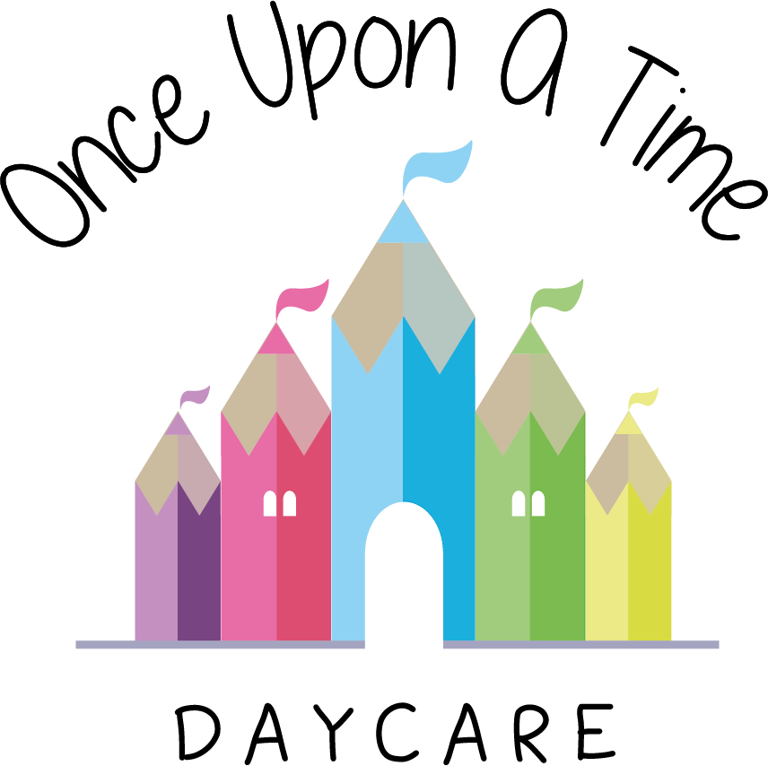

Infection Control
4b. Infection Control

EYFS: 3.44, 3.45, 3.46

At Once Upon A Time Daycare we promote the good health of all children attending through maintaining high hygiene standards and reducing the chances of infection being spread. We follow the Infection Control in Schools and other Childcare Settings guidance which sets out when and how long children need to be excluded from settings, when treatment/medication is required and where to get further advice from.

Viruses and infections can be easily passed from person to person by breathing in air containing the virus which is produced when an infected person talks, coughs or sneezes. It can also spread through hand/face contact after touching a person or surface contaminated with viruses.

We follow the guidance below to prevent a virus or infection from moving around the nursery. Our staff:
- Encourage all children to use tissues when coughing and sneezing to catch germs, then wash hands after.
- Ensure all tissues are disposed of in a hygienic way and all children and staff wash their hands once the tissue is disposed of
- Develop children’s understanding of the above and the need for good hygiene procedures in helping them to stay healthy
- Wear the appropriate Personal Protective Equipment (PPE) when changing nappies, toileting children and dealing with any other bodily fluids. Staff are requested to dispose of these in the appropriate manner and wash hands immediately
- Clean and sterilise all potties and changing mats before and after each use
- Clean toilets at least daily and check them throughout the day
- Remind children to wash their hands before eating, after visiting the toilet, playing outside or being in contact with any animal and explain the reasons for this
- Clean all toys, equipment and resources on a regular basis by following a comprehensive cleaning rota and using antibacterial cleanser or through washing in the washing machine
- Wash or clean all equipment used by babies and toddlers as and when needed including when the children have placed it in their mouth
- Store dummies in individual hygienic dummy boxes labelled with the child’s name to prevent cross-contamination with other children
- Store toothbrushes (where applicable) hygienically to prevent cross-contamination
- Immediately clean and sterilise (where necessary) any dummy or bottle that falls on the floor or is picked up by another child
- Provide labelled individual bedding for children that is not used by any other child and wash this at least once a week
- Ask parents and visitors to remove all outdoor footwear or use shoe covers when entering rooms where children may be crawling or sitting on the floor
- Where applicable wear specific indoor shoes or slippers whilst inside the rooms and make sure that children wear them as well
- Follow the sickness and illness policy when children are ill to prevent the spread of any infection in the nursery. Staff are also requested to stay at home if they are contagious.

In addition:
- The nursery manager retains the right of refusal of all children, parents, staff and visitors who are deemed contagious and may impact on the welfare of the rest of the nursery
- Parents will be made aware of the need for these procedures in order for them to follow these guidelines whilst in the nursery
- Periodically each room in the nursery will be deep cleaned including carpets and soft furnishings to ensure the spread of infection is limited. This will be implemented earlier if the need arises
- The nursery will ensure stocks of tissues, hand washing equipment, cleaning materials and sterilising fluid are maintained at all times and increased during the winter months or when flu and cold germs are circulating.

This policy was reviewed in line with the Covid 19 outbreak and additions have been added due to the changes implemented by the government and NDNA.

We will continue to implement our infection control policy, through maintaining high hygiene standards and reducing the chances of infection being spread.
In addition to this we will:
- Implement robust handwashing routines with extra stations, where possible. Hands will be washed thoroughly for 20 seconds with running water and soap, and dried thoroughly, or use alcohol hand rub/sanitiser ensuring that all parts of the hands are covered
- Clean hands on arrival at the setting, before and after eating, and after sneezing or coughing
- Encourage staff and, where age/stage appropriate, children not to touch their mouth, eyes and nose (consider face washing with children where appropriate)
- Ensure good respiratory hygiene - use a tissue or elbow to cough or sneeze and use bins for tissue waste; promoting the ‘catch it, bin it, kill it’ approach for all staff and children
- Ensure that help is available for children who have trouble cleaning their hands independently
- Encourage young children to learn and practise these habits through games, songs and repetition
- Ensure that lidded bins for tissues are emptied throughout the day
- Clean frequently touched surfaces often using standard products, such as detergents and bleach (including surfaces that children are touching, such as toys, books, tables, chairs, doors, sinks; wiping down toilets after each use, light switches, bannisters)
- Where possible, ensure spaces are well ventilated using natural ventilation (opening windows) or ventilation units
- Prop doors open, where safe to do so (bearing in mind fire safety and safeguarding), to limit use of door handles and aid ventilation
- Take steps to ensure symptomatic individuals do not attend nursery
- Minimise contact and mixing as much as possible (such as by staggered break/meal times, keeping staff and children in smaller consistent groups, ensuring that the same staff are assigned to each group as far as possible and keep children in the same rooms/areas/outdoor area throughout the day)
- Ensure play equipment is appropriately cleaned between groups of children using it and that multiple groups do not use it simultaneously.

*Children’s temperatures
Routine testing of children’s temperatures will not take place as per government guidelines. We remind parents and staff to follow national advice on Covid-19 symptoms. We ask all staff and parents to follow government advice if anyone in their household displays any symptoms.
https://www.gov.uk/government/publications/covid-19-stay-at-home-guidance/stay-at-home-guidance-for-households-with-possible-coronavirus-covid-19-infection

Anyone showing signs of coronavirus are advised to not leave their home for at least 7 days and anyone they live with should not leave their home for 14 days. This will be applied for any child, staff or family members accessing nursery.

Staff and children in all early years’ settings will be eligible for coronavirus testing if they become ill with coronavirus symptoms, as will members of their households. A negative test will enable children to get back to childcare setting, and their parents to get back to work. A positive test will ensure rapid action to protect their peers and staff in their setting.
We will work with staff and families where testing is required to arrange for this as soon as possible and ensure isolation periods are followed for all staff and children effected. See more details regarding this at
www.gov.uk/government/publications/covid-19-stay-at-home-guidance/stay-at-home-guidance-for-households-with-possible-coronavirus-covid-19-infection

If a child has a high temperature whilst at nursery, parents will be called immediately. The child will be cared for in a separate room from the other children and the staff member will, in these cases, wear a face covering to minimise the spread of infection.

Travelling to nursery – Parents, children and young people are encouraged to travel by car, walk or cycle where possible and avoid public transport at peak times. Further information and posters can be found at https://assets.publishing.service.gov.uk/government/uploads/system/uploads/attachment_data/file/884507/passenger-guidance-infographic-document.pdf

Please also refer to the Covid 19 risk assessment which outlines the risks and the procedures we are following to minimise these.

This policy was adopted on | Signed on behalf of the nursery | Date for review
1/6/18 | Rebecca Street (Manager) | 1/6/19
Date Reviewed 1/5//19 | Rebecca Street (Manger) | 1/5/20
Date Reviewed 1/3/20 | Rebecca Street (Manager) | 1/3/21
Date Reviewed 29/05/20  *Added information regarding steps we are now taking during the Covid-19 pandemic. | Rebecca Street (Manager) | 1/3/21
Date Reviewed 1/3/21 | Rebecca Street (Manager) | 1/3/22

