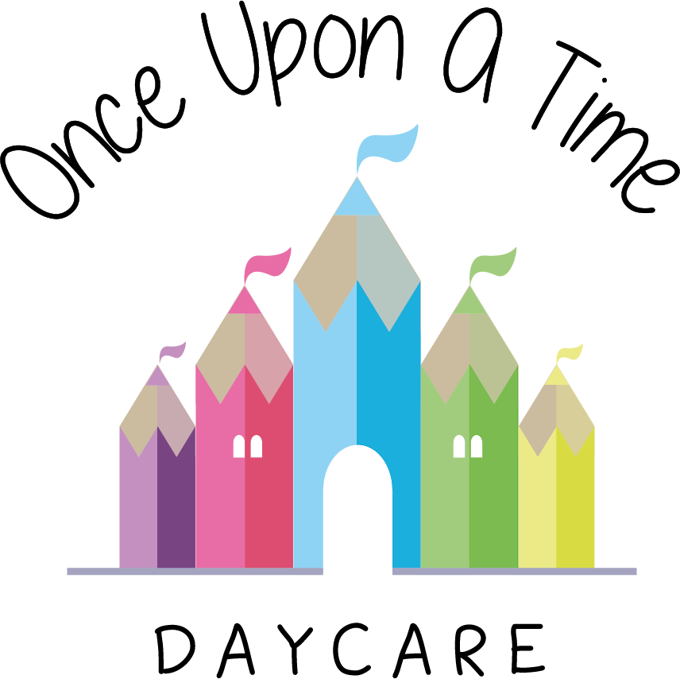

Caring for Babies and Toddlers
48. Caring for Babies and Toddlers

EYFS: 3.47, 3.48, 3.54, 3.57, 3.58, 3.59, 3.60, 3.64, 3.73

At Once Upon A Time Daycare we care for children under the age of two and ensure their health, safety and well-being through the following:
- Children under the age of two have a separate base room and are cared for in small intimate groups. We ensure that younger children have opportunities to have contact with older children whilst at nursery
- At least half of the staff team caring for children under the age of two will have undertaken specific training for working with babies
- Care is taken to ensure that babies and toddlers do not have access to activities containing small pieces, which may be swallowed or otherwise injure the child
- The environment and equipment are checked daily before the children access the area. This includes checking the stability of cots and areas around, low/highchairs and ensuring restraints on these, pushchairs and prams are intact and working
- All doors are fitted with viewing panels and door finger-guards to ensure the safety of children
- Outdoor shoes are removed or covered when entering the baby and toddler area(s). Staff remind parents and visitors to adhere to this procedure
- Babies and toddlers have their nappies changed according to their individual needs and requirements by their key person wherever possible
- Information will be shared between parents and the key person about nappy changing and toilet training in a way that suits the child
- Potties are washed and disinfected after every use. Changing mats are wiped with anti-bacterial cleanser before and after every nappy change
- Each baby must have his/her own bedding which is washed at least weekly and when necessary
- Cot mattresses meet safety standards
- Children under two years are not be given pillows, cot bumpers or any soft furnishings in order to prevent risk of suffocation
- We follow all cot death prevention/safety guidelines and advise parents of this information. Babies are always laid to sleep on their back, with their feet touching the foot of the cot
- Sheets or thin blankets will come no higher than the baby's shoulders, to prevent them wriggling under the covers. We make sure the covers are securely tucked in so they cannot slip over the baby's head
- Children’s individual sleeping bags may be used in consultation with parents. These are washed at least weekly and when necessary
- Cots are checked before use to ensure no items are within reach i.e. hanging over or beside the cot (e.g. fly nets, cables)
- All low/highchairs used for feeding are fitted with restraints and these are used at all times. Children are never left unattended in high chairs. Restraints are removed and washed weekly or as needed
- No child is ever left unattended during nappy changing time
- Babies are never left propped up with bottles as it is both dangerous and inappropriate
- Babies sleeping outside have cat/fly nets over their prams and prams must lie flat so children are supported
- Sleeping children are supervised at all times
- Checks on sleeping babies are completed every 10 minutes. This may increase to five minutes for younger babies and or new babies. Checks are documented with the time and staff initials on the sleep check form
- Staff do not change nappies whilst pregnant until a risk assessment has been discussed and conducted. Students only change nappies with the support and close supervision of a qualified member of staff
- Where food/milk is prepared for babies there is a separate area within the kitchen which is specifically designated for this preparation
- Bottles of formula milk are only be made up as and when the child needs them. These should be cooled to body temperature, which means they should feel warm or cool, but not hot, and should be tested with a sterilised thermometer to ensure they are an appropriate temperature for the child to drink safely
- Following the Department of Health guidelines, we only use recently boiled water to make formula bottles (left for no longer than 30 minutes to cool). We do not use cooled boiled water that is reheated
- Bottles and teats are thoroughly cleaned with hot soapy water and sterilised after use (they will not be washed in the dishwasher)
- Contents of bottles are disposed of after two hours
- A designated area is available for mothers who wish to breastfeed their babies or express milk
- Labelled mothers’ breast milk is stored in the fridge
- If dummies are used they will be cleaned and sterilised. This also applies to dummies which have been dropped (see separate dummy policy)
- All dummies are stored in separate labelled containers to ensure no cross-contamination occurs
- Sterilisers are washed out and cleaned daily
- Children transfer to the older age group when assessed as appropriate for their age/stage following our agreed transition and settling procedures.

This policy was adopted on | Signed on behalf of the nursery | Date for review
1/6/18 | Rebecca Street (Manager) | 1/6/19
Date Reviewed 1/5//19 | Rebecca Street (Manger) | 1/5/20
Date Reviewed 1/3/20 | Rebecca Street (Manager) | 1/3/21
Date Reviewed 1/3/21 | Rebecca Street (Manager) | 1/3/22

