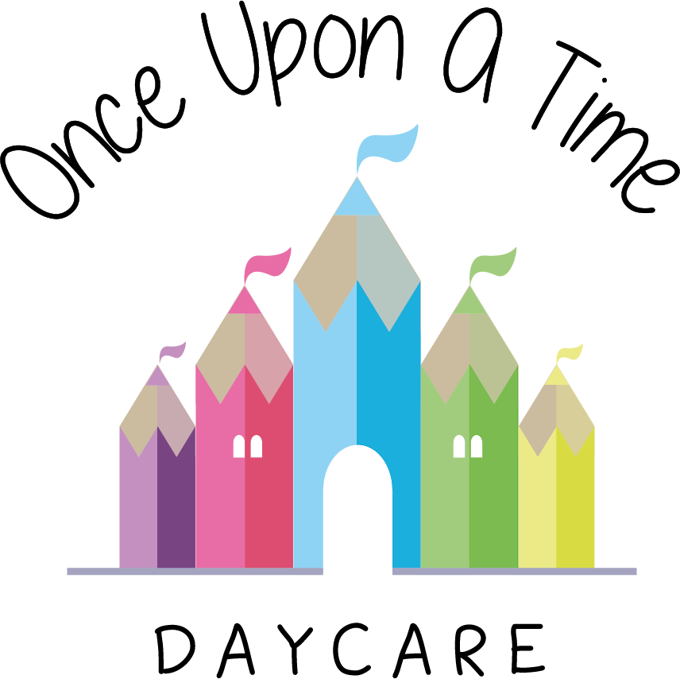

Outdoor Play
47. Outdoor Play

EYFS: 1.3, 3.58

At Once Upon A Time Daycare we are committed to the importance of daily outdoor play and the physical development of all children regardless of their age and stage of development. We provide outdoor play in all weathers. Where possible and appropriate, we make outdoor activities accessible to children with learning difficulties and disabilities to ensure inclusive use of the outdoor area.

We recognise that children need regular access to outdoor play in order to keep fit and healthy, develop their large and fine motor skills, experience learning in a natural environment and access sunlight in order to absorb vitamin D more effectively. We also refer to The Chief Medical Office guidance on physical activity.

The outdoor areas, both within the nursery grounds and in the local community have a wealth of experiences and resources which help children to develop in a variety of ways, including independence, exploration and investigative skills, risk taking and self-esteem, all of which support children to develop skills now and for the future.

We ensure all areas are safe and secure through close supervision and the use of robust risk assessments and daily safety checks. Where possible and appropriate, we plan and encourage play that helps children understand and manage risks. This type of play allows children to explore and find their own boundaries in a safe environment with supportive practitioners. Staff are informed of the importance of safety procedures and are trained appropriately to ensure these procedures are followed effectively.

We obtain parental permission before any child leaves the nursery during the day. This includes short outings into the local community. There is more information in the outings policy.

We plan all outdoor play opportunities and outings to complement the indoor activities and provide children with purposeful activities that support and follow individual children’s interests. There is a balance of both adult-led and child-initiated opportunities to enable children to learn and practice new skills, knowledge and behaviours.

We use this policy alongside the following policies to ensure the safety and welfare of children throughout their time outside:
- Health and Safety
- Sun Care
- Caring for Babies and Toddlers
- Lost Child Policy
- Parents and Carers as Partners
- Supervision of Children
- Safeguarding and Child Protection
- Outings.

This policy was adopted on | Signed on behalf of the nursery | Date for review
1/6/18 | Rebecca Street (Manager) | 1/6/19
Date Reviewed 1/5//19 | Rebecca Street (Manger) | 1/5/20
Date Reviewed 1/3/20 | Rebecca Street (Manager) | 1/3/21
Date Reviewed 1/3/21 | Rebecca Street (Manager) | 1/3/22
*During Covid-19 we have formed room ‘Bubbles’ as the main outdoor area for over 2’s is a shared space, the bubbles are not permitted to mix so now have separate outdoor times to ensure there is no mixing of bubbles.

www.gov.uk/government/publications/uk-physical-activity-guidelines

