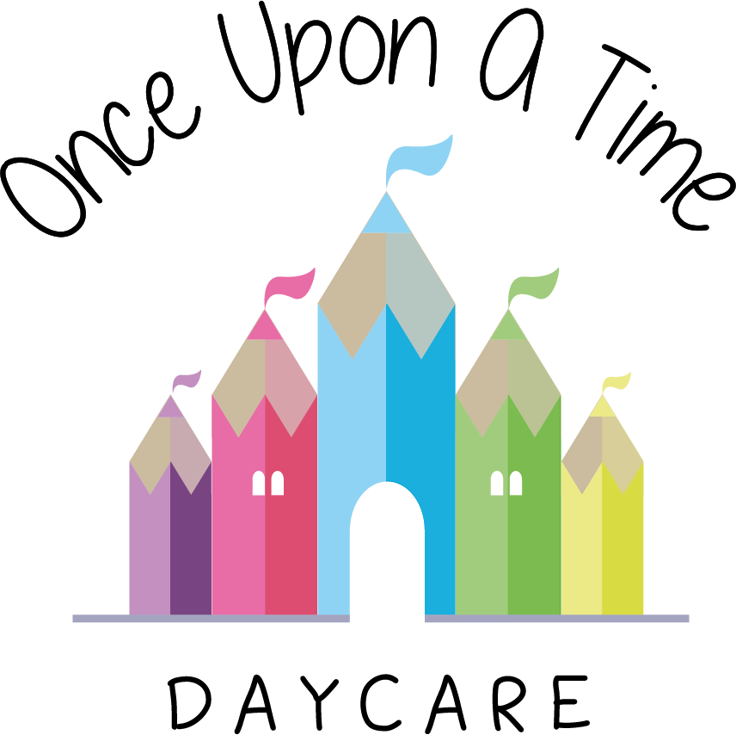

Nappy Changing
46. Nappy Changing

EYFS: 3.27, 3.60, 3.73

At Once Upon A Time Daycare we aim to support children’s care and welfare on a daily basis in line with their individual needs. All children need contact with familiar, consistent carers to ensure they can grow confidently and feel self-assured. Wherever possible, each child’s key person will change nappies according to the child’s individual needs and requirements.

Our procedures meet best practice identified by the Health Protection Agency (2011) in ‘Best practice advice for nurseries and childcare settings’.

We will enable a two-way exchange between parents and key persons so that information is shared about nappy changing and toilet training in a way that suits the parents and meets the child’s needs. Parents will be engaged in the process of potty training and supported to continue potty training with their child at home.

We will use appropriate designated facilities for nappy changing which meet the following criteria:
- Facilities are separate to food preparation and serving areas and children’s play areas
- Changing mats have a sealed plastic covering and are frequently checked for cracks or tears. If cracks or tears are found, the mat is discarded. Disposable towels/roll are placed on top of the changing mat for added protection
- Clean nappies are stored in a clean dry place; soiled nappies are placed in a ‘nappy sack’ or plastic bag before being placed in the bin. Bins are foot-pedal operated, regularly emptied and placed in an appropriate waste collection area. Each child should have their own creams and lotions for any non-prescription cream for skin conditions e.g. Sudocrem. These are supplied by the parent/guardian and must be clearly labelled with the child’s name. Prior written permission is obtained from the parent. When applying creams for rashes, a gloved hand is used.

Staff changing nappies will:
- Use a new disposable apron and pair of gloves for each nappy change and always wash hands before and after using gloves
- Clean disinfect and dry mats thoroughly after each nappy change; disposable towels/roll must be discarded after each nappy change
- Ensure they have all the equipment they need and access to fresh water before each nappy change.
- Ensure that children’s nappies are changed regularly with no more than 4 hours in between.

We wish to ensure the safety and welfare of the children whilst being changed and safeguard against any potential harm as well as ensuring the staff member involved is fully supported and able to perform their duties safely and confidently. We aim to support all parties through the following actions:
- Promoting consistent and caring relationships through the key person system in the nursery and ensuring all parents understand how this works and who they will be working with
- Using this one-to-one time as a key opportunity to talk to children and help them learn, e.g. through singing and saying rhymes during the change
- Ensuring that the nappy changing area is inviting and stimulating and change this area regularly to continue to meet children’s interests
- Ensuring all staff undertaking nappy changing have suitable enhanced DBS checks
- Training all staff in the appropriate methods for nappy changing
- Ensuring that no child is ever left unattended during the nappy changing time
- Making sure staff do not change nappies whilst pregnant until a risk assessment has been discussed and conducted; and that students only change nappies with the support and close supervision of a qualified member of staff
- Conducting thorough inductions for all new staff to ensure they are fully aware of all nursery procedures relating to nappy changing
- Ensuring hygiene procedures are followed appropriately, e.g. hands washed before and after nappies are changed and changing mats cleaned before and after each use
- Ensure children are regularly checked between scheduled nappy changes.
- Following up procedures through supervision meetings and appraisals to identify any areas for development or further training
- Working closely with parents on all aspects of the child’s care and education as laid out in the parent and carers as partner’s policy. This is essential for any intimate care routines which may require specialist training or support. If a child requires specific support the nursery will arrange a meeting with the parent to discover all the relevant information relating to this to enable the staff to care for the child fully and meet their individual needs
- Ensuring all staff have an up-to-date understanding of child protection and how to protect children from harm. This includes identifying signs and symptoms of abuse and how to raise these concerns as set out in the child protection policy
- Operating a whistleblowing policy to help staff raise any concerns relating to their peers or managers and helping staff develop confidence in raising concerns as they arise in order to safeguard the children in the nursery
- Conducting working practice observations of all aspects of nursery operations to ensure that procedures are working in practice and all children are supported fully by the staff. This includes all intimate care routines
- Conducting regular risk assessments of all aspects of nursery operations including intimate care and reviewing the safeguards in place. The nursery has assessed all the risks relating to intimate care routines and has placed appropriate safeguards in place to ensure the safety of all involved.

If any parent or member of staff has concerns or questions about nappy changing procedures or individual routines, please see the manager at the earliest opportunity.

This policy was adopted on | Signed on behalf of the nursery | Date for review
1/6/18 | Rebecca Street (Manager) | 1/6/19
Date Reviewed 1/5//19 | Rebecca Street (Manger) | 1/5/20
Date Reviewed 1/3/20 | Rebecca Street (Manager) | 1/3/21
Date Reviewed 1/3/21 | Rebecca Street (Manager) | 1/3/22

