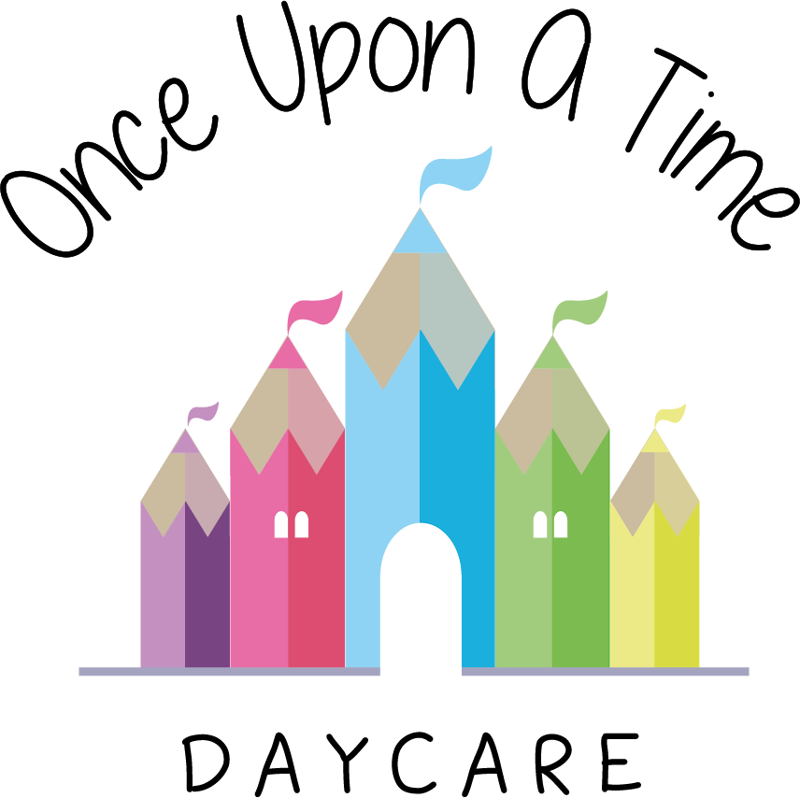

Separated Family
45. Separated Family

EYFS: 3.27, 3.72

At Once Upon A Time Daycare we recognise that when parents separate it can be a difficult situation for all concerned. We understand that emotions may run high and this policy sets out how we will support the all parties in within the nursery including our staff team. The key person will work closely with the parents to build close relationships which will support the child’s/children’s emotional wellbeing and report any significant changes in behaviour to the parent. Parents will be signposted to relevant services and organisation for support for the whole family.

Parental responsibility
While the law does not define in detail what parental responsibility is, the following list sets out some of the key features of someone holding parental responsibility. These include:
- Providing a home for the child
- Having contact with and living with the child
- Protecting and maintaining the child
- Disciplining the child
- Choosing and providing for the child's education
- Determining the religion of the child
- Agreeing to the child's medical treatment
- Naming the child and agreeing to any change of the child's name
- Accompanying the child outside the UK and agreeing to the child's emigration, should the issue arise
- Being responsible for the child's property
- Appointing a guardian for the child, if necessary
- Allowing confidential information about the child to be disclosed.

England
If the parents of a child are married to each other at the time of the birth, or if they have jointly adopted a child, then they both have parental responsibility. Parents do not lose parental responsibility if they divorce, and this applies to both the resident and the non-resident parent.

This is not automatically the case for unmarried parents. According to current law, a mother always has parental responsibility for her child. However, a father has this responsibility only if he is married to the mother when the child is born or has acquired legal responsibility for his child through one of these three routes:
- By jointly registering the birth of the child with the mother (From 1 December 2003)
- By a parental responsibility agreement with the mother
- By a parental responsibility order, made by a court.

Nursery registration
During the registration process we collect details about both parents including who has parental responsibility, as this will avoid any future difficult situations.
We request these details on the child registration form. If a parent does not have parental responsibility, or has a court order in place to prevent this, we must have a copy of this documentation for the child’s records.

If a child is registered by one parent of a separated family, we request disclosure of all relevant details relating to the child and other parent such as court orders or injunctions. This will make sure we can support the child and family fully in accordance with the policy set out below.

We will:
- Ensure the child’s welfare is paramount at all times they are in the nursery
- Comply with any details of a court order where applicable to the child’s attendance at the nursery where we have seen a copy/have a copy attached to the child’s file
- Provide information on the child’s progress, e.g. learning journeys, progress checks within the nursery, to both parents where both hold parental responsibility
- Invite both parents to nursery events, including parental consultations and social events where both hold parental responsibility
- Ensure any incident or accident within the nursery relating to the child is reported to the person collecting the child
- Ensure that all matters known by the staff pertaining to the family and the parent’s separation remain confidential
- Ensure that no member of staff takes sides regarding the separation and treats both parents equally and with due respect
- Not restrict access to any parent with parental responsibility unless a formal court order is in place. We respectfully ask that parents do not put us in this position.

We ask parents to:
- Provide us with all information relating to parental responsibilities, court orders and injunctions
- Update information that changes any of the above as soon as practicably possible
- Work with us to ensure continuity of care and support for your child
- Not involve nursery staff in any family disputes, unless this directly impacts on the care we provide for the child
- Talk to the manager/key person away from the child when this relates to family separation in order to avoid the child becoming upset. This can be arranged as a more formal meeting or as an informal chat
- Not ask the nursery to take sides in any dispute. We will only take the side of your child and this will require us to be neutral at all times.

This policy was adopted on | Signed on behalf of the nursery | Date for review
1/6/18 | Rebecca Street (Manager) | 1/6/19
Date Reviewed 1/5//19 | Rebecca Street (Manger) | 1/5/20
Date Reviewed 1/3/20 | Rebecca Street (Manager) | 1/3/21
Date Reviewed 1/3/21 | Rebecca Street (Manager) | 1/3/22

