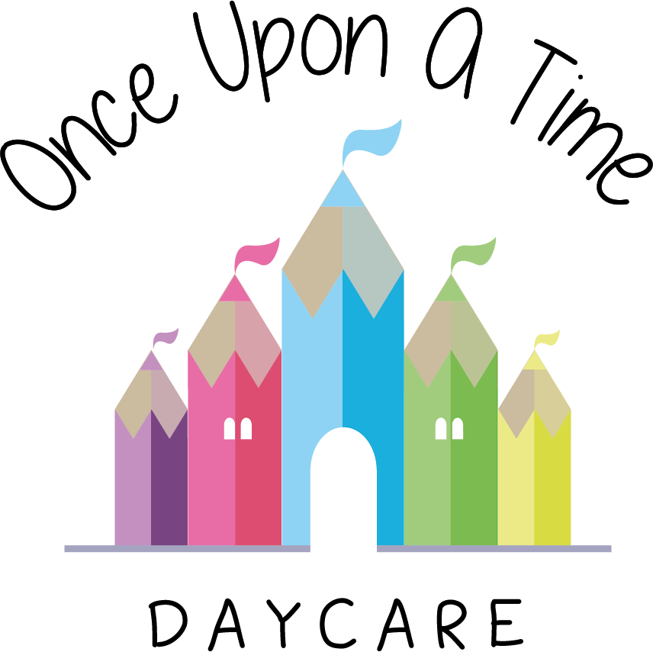

Transitions
44. Transitions

At Once Upon A Time Daycare we recognise that young children will experience many transitions in their early years; some of these planned and some unplanned. We are sensitive to the impact of such changes to children and this policy sets out the ways in which we support children going through these transitions.

Some examples of transitions that young children and babies may experience are:
- Starting nursery
- Moving between different rooms within the nursery
- Starting school or moving nurseries
- Family breakdowns
- New siblings
- Moving home
- Death of a family member or close friend
- Death of a family pet.

Staff are trained to observe their key children and to be sensitive to any changes in their behaviour and personality. We respectfully ask that parents inform us of any changes in the home environment that may impact on their child so staff can be aware of the reasons behind any potential changes in the child’s behaviour.

Starting nursery
We recognise that starting nursery may be difficult for some children and their families. We have a settling in policy to support the child and their family.

Moving rooms procedure
When a child is ready to move to a different room in the nursery, we follow the process set out below and work with the parents to ensure this is a seamless process in which the child is fully supported at all stages. This may include a handover meeting between the existing key person, new key person and parents.
- The child will spend short sessions in their new room prior to the permanent move to enable them to feel comfortable in their new surroundings
- The child’s key person will go with the child on these initial visits to enable a familiar person to be present at all times
- Wherever possible groups of friends will be moved together to enable these friendships to be kept intact and support the children with the peers they know
- Parents will be kept informed of all visits and the outcomes of these sessions e.g. through photographs, discussions or diary entries
- Only when the child has settled in through these taster sessions will the permanent room move take place. If a child requires more support this will be discussed between the key person, parent, manager and room leader of the new room to agree how and when this will happen. This may include moving their key person with them on a temporary basis.

Starting school or moving childcare providers
Starting school is an important transition and some children may feel anxious or distressed. We will do all we can to facilitate a smooth move and minimise any potential stresses. This following process relates to children going to school. However wherever possible, we will adapt this process to support children moving to another childcare provider e.g. childminder or another nursery.
- We provide a variety of resources that relate to the school, e.g. uniform to dress up in, a role play area set up as a school classroom, photographs of all the schools the children may attend. This will help the children to become familiar with this new concept and will aid the transition
- We invite school representatives into the nursery to introduce them to the children
- Where possible we use other ways to support the transition to school, e.g. inviting previous children from the nursery who have moved on to school to come back and talk to the children about their school experiences
- Where possible we plan visits to the school with the key person. Each key person will talk about the school with their key children who are due to move to school and discuss what they think may be different and what may be the same. They will talk through any concerns the child may have and initiate activities or group discussions relating to any issues to help children overcome these
- We produce a comprehensive report on every child starting school to enable teachers to have a good understanding of every child received. This will include their interests, strengths and level of understanding and development in key areas. This will support continuity of care and early learning.

Other early years providers
Where children are attending other early years settings or are cared for by a childminder we will work with them to share relevant information about children’s development. Where a child is brought to nursery or collected from nursery by a childminder we will ensure that key information is being provided to the child’s parent by providing the information directly to the parent via email or telephone.

Family breakdowns
We recognise that when parents separate it can be a difficult situation for all concerned. We have a separated families policy that shows how the nursery will act in the best interest of the child.

Moving home and new siblings
We recognise that both these events may have an impact on a child. Normally, parents will have advance notice of these changes and we ask parents to let us know about these events so we can support the child to be prepared. The key person will spend time talking to the child and providing activities that may help the child to act out any worries they have, e.g. through role play, stories and discussions.

Bereavement
We recognise that this may be a very difficult time for children and their families and have a separate policy on bereavement which we follow to help us offer support to all concerned should this be required.

If parents feel that their child requires additional support because of any changes in their life, we ask that you speak to the nursery manager and the key person to enable this support to be put into place.

This policy was adopted on | Signed on behalf of the nursery | Date for review
1/6/18 | Rebecca Street (Manager) | 1/6/19
Date Reviewed 1/5//19 | Rebecca Street (Manger) | 1/5/20
Date Reviewed 1/3/20 | Rebecca Street (Manager) | 1/3/21
Date Reviewed 1/3/21 | Rebecca Street (Manager) | 1/3/22

