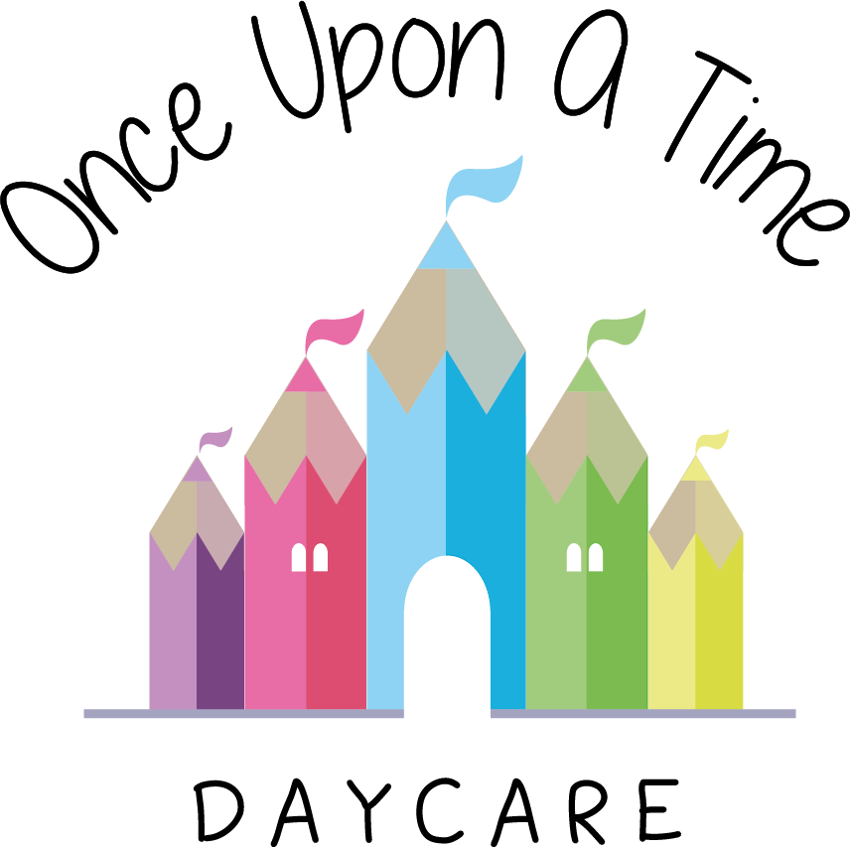

Settling In
43. Settling In

EYFS: 3.27, 3.73
3.26, 3.72

At Once Upon A Time Daycare we aim to support parents and other carers to help their children settle quickly and easily by giving consideration to the individual needs and circumstances of every child and their families. Our aim is for children to feel safe, stimulated and happy in the nursery and to feel secure and comfortable with all staff. We also want parents to have confidence in both their children's continued well-being and their role as active partners, with the child being able to benefit from what the nursery has to offer.

All our staff know about the importance of building strong attachments with children. They are trained to recognise the different stages of attachment and use this knowledge to support children and families settling in to the nursery.

Our nursery will work in partnership with parents to settle their child into the nursery environment by:
- Allocating a key person to each child and his/her family, before he/she starts to attend. The key person welcomes and looks after the child ensuring that their care is tailored to meet their individual needs. He/she offers a settled relationship for the child and builds a relationship with his/her parents during the settling in period and throughout his/her time at the nursery, to ensure the family has a familiar contact person to assist with the settling in process
- Providing parents with relevant information about the policies and procedures of the nursery
- Encouraging parents and children to visit the nursery during the weeks before an admission is planned and arranging home visits where applicable
- Planning settling in visits and introductory sessions (lasting approximately 1-2 hours). The first three will be provided free of charge over a one or two week period, dependent on individual needs, age and stage of development
- Parents are able to pay for additional hours if they feel this will benefit their child
- Welcoming parents to stay with their child during the first few weeks until the child feels settled and the parents feel comfortable about leaving their child. Settling in visits and introductory sessions are key to a smooth transition and to ensure good communication and information sharing between staff and parents
- Reassuring parents whose children seem to be taking a long time settling in to the nursery and developing a plan with them
- Encouraging parents, where appropriate, to separate themselves from their children for brief periods at first, gradually building up to longer absences
- Assigning a buddy/back-up key person to each child in case the key person is not available. Parents will be made aware of this to support the settling process and attachment
- Reviewing the nominated key person if the child is bonding with another member of staff to ensure the child’s needs are supported
- Respecting the circumstances of all families, including those who are unable to stay for long periods of time in the nursery and reassure them of their child’s progress towards settling in
- Not taking a child on an outing from the nursery until he/she is completely settled.

This policy was adopted on | Signed on behalf of the nursery | Date for review
1/6/18 | Rebecca Street (Manager) | 1/6/19
Date Reviewed 1/5//19 | Rebecca Street (Manger) | 1/5/20
Date Reviewed 1/3/20 | Rebecca Street (Manager) | 1/3/21
Date Reviewed 1/3/21 | Rebecca Street (Manager) | 1/3/22
*Due to Covid-19 and in line with our Covid-19 risk assessments parents are unable to enter the room. The first settle takes place in our office/settling in room with just one parent, the child and their key worker.

