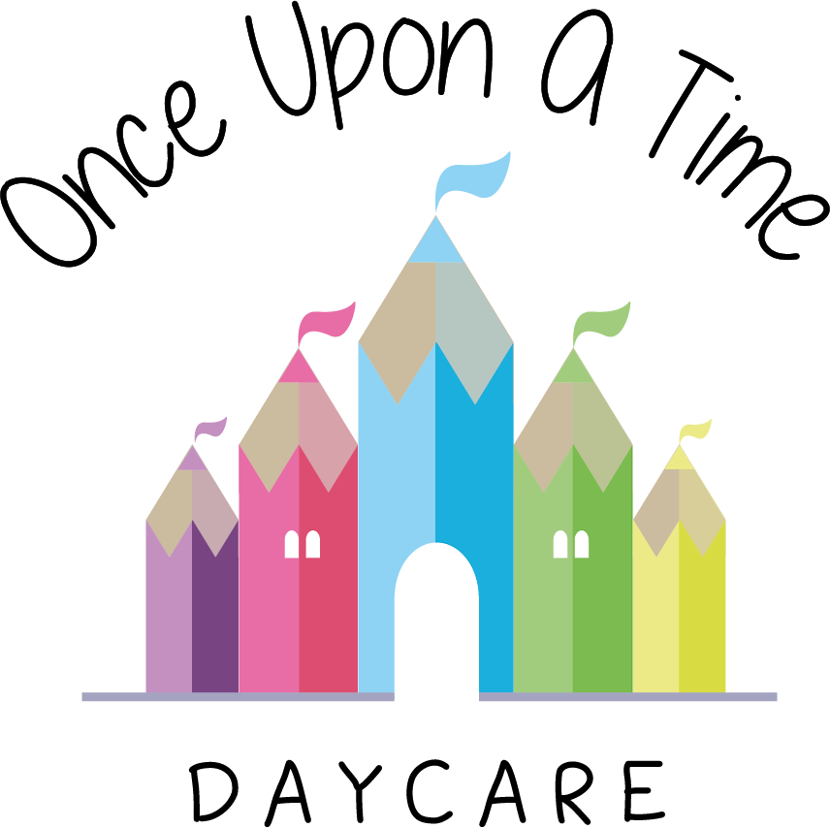

Sun Care
41. Sun Care

At Once Upon A Time Daycare we are committed to ensuring that all children are fully protected from the dangers of too much sun/UV rays. Severe sunburn in childhood can lead to the development of malignant melanoma (the most dangerous type of skin cancer) in later life.

We follow guidance from the weather and UV level reports and use the following procedures to keep children safe and healthy in the sun:
- Key persons will work with the parents of their key children to decide and agree on suitable precautions to protect children from burning, including those with more sensitive skin types and those that may be more tolerant to the sunshine, e.g. black and/or Asian colouring
- Children must have a clearly labelled sun hat which will be worn at all times whilst outside in sunny weather. This hat will preferably be of legionnaires design (i.e. with an extended back and side to shield children’s neck and ears from the sun) to provide additional protection
- The nursery will provide a high factor children’s sun protection and will be applied with prior written consent form the parents/carers. The parents/carers will provide the nursery with an alternative if the nursery’s is not appropriate for their child.
- Parents are requested to supply light-weight cotton clothing for their children suitable for the sun, with long sleeves and long legs
- Children’s safety and welfare in hot weather is the nursery’s prime objective so staff will work closely with parents to ensure all appropriate cream and clothing is provided
- Staff will make day-to-day decisions about the length of time spent outside depending on the strength of the sun; children will not be allowed in the direct sunlight between 11.00am – 3.00pm on hot days. The UV rays will be checked on a daily basis in the summer months to ensure children’s safety in the sun.
- Children will always have sun cream applied before going outside in the hot weather and at frequent intervals during the day
- Children are encouraged to drink cooled water more frequently throughout sunny or warm days and this will be accessible both indoors and out
- Children are made aware of the need for sun hats, sun cream and the need to drink more fluids during their time in the sun
- Shade will be provided to ensure children are able to still go out in hot weather, cool down or escape the sun should they wish or need to.

This policy was adopted on | Signed on behalf of the nursery | Date for review
1/6/18 | Rebecca Street (Manager) | 1/6/19
Date Reviewed 1/5//19 | Rebecca Street (Manger) | 1/5/20
Date Reviewed 1/3/20 | Rebecca Street (Manager) | 1/3/21
Date Reviewed 1/3/21 | Rebecca Street (Manager) | 1/3/22

