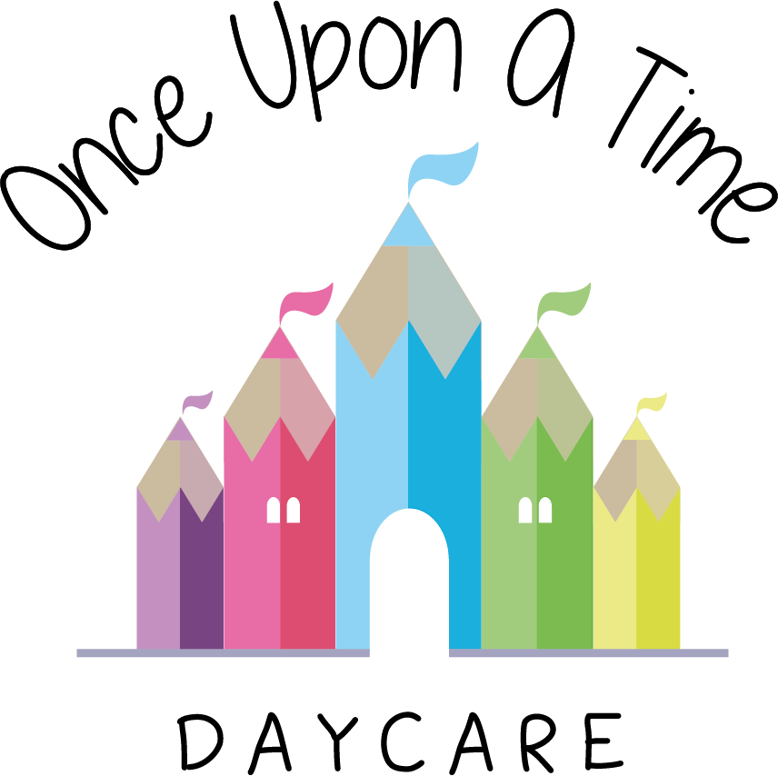

Immunisation
39. Immunisation

At Once Upon A Time Daycare we expect that children are vaccinated in accordance with the government’s health policy and their age. We ask that parents inform us if their children are not vaccinated so that we can manage any risks to their own child or other children/staff/parents in the best way possible. The nursery manager must be aware of any children who are not vaccinated within the nursery in accordance with their age.

We make all parents aware that some children in the nursery may not be vaccinated, due to their age, medical reasons or parental choice. Our nursery does not discriminate against children who have not received their immunisations and will not disclose individual details to other parents. However, we will share the risks of infection if children have not had immunisations and ask parents to sign a disclaimer.

We record, or encourage parents to record, information about immunisations on children’s registration documents and we update this information as and when necessary, including when the child reaches the age for the appropriate immunisations.

Staff vaccinations policy
It is the responsibility of all staff to ensure they keep up-to-date with their vaccinations, as recommended by the NHS vaccination schedule and keep the nursery informed.

If a member of staff is unsure as to whether they are up-to-date, then we recommend that they visit their GP or practice nurse for their own good health.

Emergency information
We keep emergency information for every child and update it every six months with regular reminders to parents in newsletters, at parents’ evenings and a reminder notice on the Parent Information Board.

This policy was adopted on | Signed on behalf of the nursery | Date for review
1/6/18 | Rebecca Street (Manager) | 1/6/19
Date Reviewed 1/5//19 | Rebecca Street (Manger) | 1/5/20
Date Reviewed 1/3/20 | Rebecca Street (Manager) | 1/3/21
Date Reviewed 1/3/21 | Rebecca Street (Manager) | 1/3/22

