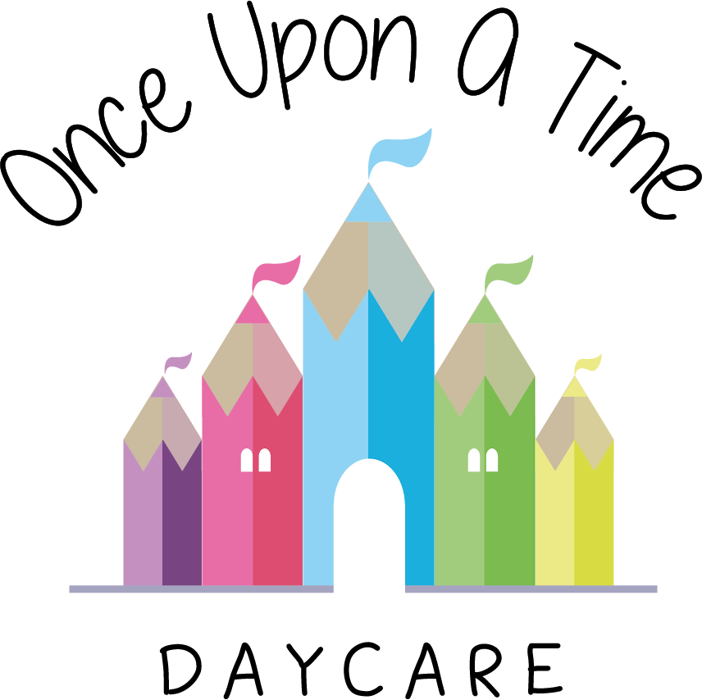

Volunteers
34. Volunteers

EYFS: 3.9, 3.29

At Once Upon A Time Daycare we recognise the immense benefits that volunteers bring to the nursery. In return we hope to give volunteers an opportunity to share their skills in a different environment and to undertake new experiences.

Status of volunteers
A volunteer is not an employee and will not have a contract of employment with the nursery. We will, however, insist that the volunteer follows all nursery procedures in the same manner as a paid employee to ensure consistency, safety and quality of care and early learning for the children. Volunteers will be supervised at all times.

Enhanced Disclosure and Barring Service (DBS) check
All volunteers will have suitability checks conducted in the same way as paid employees. This will include an enhanced DBS check. These checks will be conducted before any volunteer starts their time within the nursery and will also include two written references.

Training
Volunteers will be offered training and/or support as appropriate. We will provide any training and support required for the role, including child protection and health and safety training. The purpose of this is to enable the volunteer to be supported and enhance their development in their voluntary role within our team.

Policies and procedures
Volunteers are expected to comply with all the nursery’s policies and procedures. The volunteer’s induction process will include an explanation of this.

Confidentiality
Volunteers should not disclose information about the nursery, staff, children and families as stated in the confidentiality policy and should follow the nursery confidentiality procedure at all times.

Volunteer's induction pack
On commencing their volunteer work, the volunteer will be given a pack containing:
- General information about the nursery
- A copy of the volunteering policy
- A confidentiality statement which will require reading, signing and returning to the nursery manager
- Details of access to all nursery relevant policies and procedures.

Volunteer support
The nursery has a designated officer who will take the volunteer through their induction and support and advise them throughout their time in the nursery. Our designated officer for volunteers is Rebecca Street.

This policy was adopted on | Signed on behalf of the nursery | Date for review
1/6/18 | Rebecca Street (Manager) | 1/6/19
Date Reviewed 1/5//19 | Rebecca Street (Manger) | 1/5/20
Date Reviewed 1/3/20 | Rebecca Street (Manager) | 1/3/21
Date Reviewed 1/3/21 | Rebecca Street (Manager) | 1/3/22
*Although we appreciate the support and value volunteers offer to our nursery, we have decided that during the pandemic period we will not be permitting volunteers in the nursery to care and support the children at this time. This is because we are trying to limit the number of people in nursery at any one time. We will review this in line with Government policy and updates, and review accordingly.

