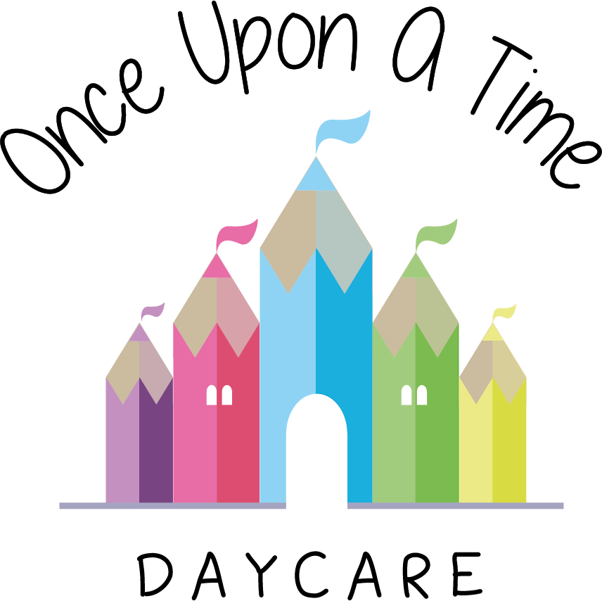

Suitability of Staff
31. Suitability of Staff

EYFS: 3.9 – 3.18, 3.20-3.26

At Once Upon A Time Daycare we are committed to ensuring that all staff, including students and volunteers are suitable to work with or be in regular contact with children. We have systems in place to ensure that this includes making a decision about suitability, as part of the recruitment process and monitoring continued suitability, as part of regular staff or student supervision.

The nursery manager is responsible for ensuring that all staff and students have an enhanced check with the Disclosure and Barring Service (DBS), and that the results of such a check are assessed as part of a decision on suitability. Where possible staff will have the checks completed prior to starting employment. However, if there are delays in checks coming through, as a last resort staff may work in the nursery before these checks are completed as long as they are supervised at all times by staff who already hold an enhanced check and the check has been applied for.

All nursery staff will be informed of any staff awaiting enhanced DBS clearance.

Staff awaiting these checks will never:
- Be left unsupervised whilst caring for children
- Take children for toilet visits unless supervised by staff holding an enhanced check
- Change nappies
- Be left alone in a room or outside with children
- Administer medication
- Administer first aid
- Take photographs of any children
- Be involved in looking at a child’s learning and development log, but can contribute to it
- Have access to children’s personal details and records.

While adhering to the above list, we recognise that it is vital that the staff member awaiting an enhanced disclosure is made to feel part of the team and we support them in participating fully in every other aspect of the nursery day.

We recognise that the enhanced DBS disclosure is only one part of a suitability decision and nursery management will ensure every individual working with a child goes through a vigorous recruitment and induction procedure (as laid out in the safe recruitment policy). We will also ensure they receive continuous support, training and supervision from management in order to provide a safe, secure and healthy environment for all children in the nursery. We act on any information that comes to our attention that suggests someone may no longer be suitable for their role.

All students will also receive an interview to ensure they are suitable for the nursery and an induction process to ensure they fully understand and are able to implement the nursery procedures, working practices and values. All students will be fully supervised to ensure they receive the appropriate support, training and information they may require.

This policy was adopted on | Signed on behalf of the nursery | Date for review
1/6/18 | Rebecca Street (Manager) | 1/6/19
Date Reviewed 1/5//19 | Rebecca Street (Manger) | 1/5/20
Date Reviewed 1/3/20 | Rebecca Street (Manager) | 1/3/21
Date Reviewed 1/3/21 | Rebecca Street (Manager) | 1/3/22

