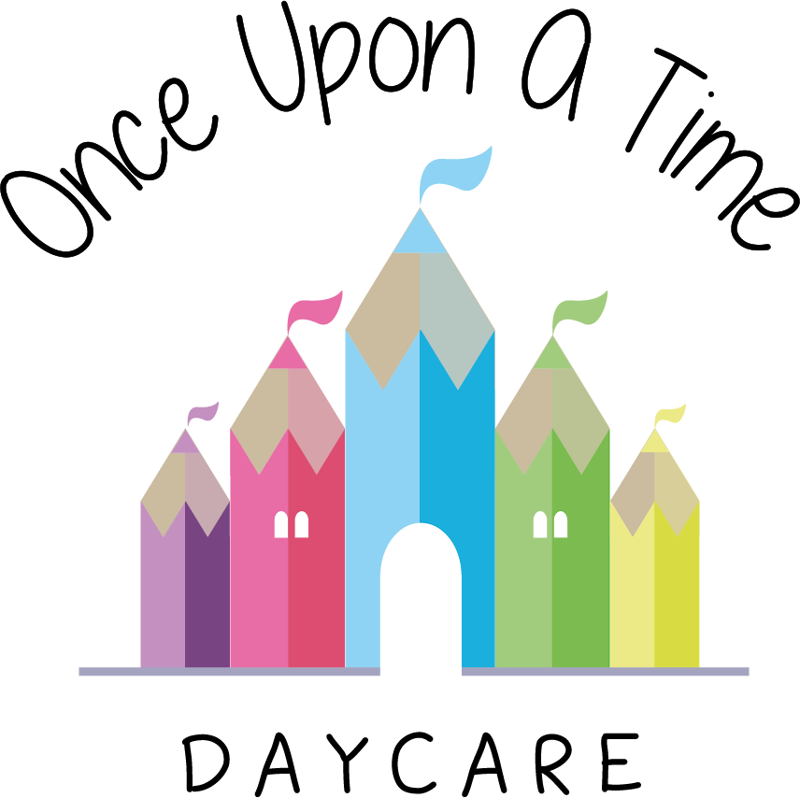

Looked After Children
2d. Looked After Children

EYFS: 3.1, 3.2, 3.4, 3.6, 3.20

At Once Upon A Time Daycare we are committed to providing a welcoming and inclusive quality environment for all children and families.

Definition and legal framework
The description ‘looked after’ is generally used to describe a child who is looked after by the local authority. This includes children who are subject to a care order or temporarily classed as looked after on a planned basis for short breaks or respite care. Most looked after children will be cared for by foster carers with a small minority in children’s homes, looked after by family members or even placed back within the family home.

The term 'looked after child' denotes a child's current legal status. The nursery never uses this term to categorise a child as standing out from others or refers to a child using acronyms such as LAC.

The legal framework for this policy is underpinned by or supported through:
- Childcare Act 2006
- Children Act (1989 and 2004)
- Adoption and Children Act (2002)
- Children and Young Persons Act (2008)
- Children and Families Act (2014).

Our policy
Our nursery treats each child as an individual. We recognise that for young children to get the most out of educational opportunities they need to be settled appropriately with their carer. We will discuss with the child’s carer, and social worker where applicable, the length of time the child has been with the carer before they start nursery to establish how secure the child feels and whether they are ready to be able to cope with further separation, a new environment and new expectations made upon them.

We are aware that there are a number of reasons why a child may go into care and these reasons may or may not include traumatic experiences or abuse. All our practitioners are committed to doing all they can to support all children to achieve their full potential. The nursery staff team are all trained to understand our safeguarding policy and procedures. Additional training to support children’s individual needs will be planned for where appropriate. Practitioners are supported by management at all times and we have an open door policy if they need to discuss any sensitive issues regarding the child.

Where applicable, we contribute to any assessment about the child, such as those carried out under local authorities’ assessment frameworks or Early Help Assessment (EHA) and to any multi-agency meetings, case conferences or strategy meetings in relation to the child’s learning and development. The designated person for looked after children and/or the child’s key person will attend meetings as appropriate.

The designated person for ‘looked after children’ is Samijo Street.

Each child is allocated a key person. The key person will support the child initially with transition and settling in and then continue to support and build up a relationship with the child, carers and any other agencies involved. Regular contact will be maintained with the carers throughout the child’s time at the nursery and with the social worker or other professionals (where applicable).

The key person will carry out regular ongoing practice such as observations to build up a picture of the child’s interests, and plan activities accordingly to support the child’s stage of learning and development and interests. This information will be shared with carers and other professionals as appropriate as well as any concerns surrounding their developmental stages.

Where necessary we will develop a care plan with carers and professionals. This will include:
- The child's emotional needs and how they are to be met
- How any emotional issues and problems that affect behaviour are to be managed
- The child's sense of self, culture, language/s and identity - how this is to be supported
- The child's need for sociability and friendship
- The child's interests and abilities and possible learning journey pathway
- How any special needs will be supported.

In addition, the care plan may also consider:
- How information will be shared with the foster carer and local authority (as the 'corporate parent') as well as what information is shared with any other organisation or professionals and how it will be recorded and stored
- What contact the child has with his/her birth parent(s) and what arrangements will be in place for supervised contact. If this is to be in the setting, when, where and what form the contact will take will be discussed and agreed
- Who may collect the child from nursery and who may receive information about the child
- What written reporting is required
- Wherever possible, and where the plan is for the child to return to their home, the birth parent(s) should be involved in planning
- With the social worker's agreement, and as part of the plan, whether the birth parent(s) should be involved in the setting's activities that include parents, such as outings, fun days etc. alongside the foster carer.

Where applicable, we will complete a Personal Education Plan (PEP) for any children aged three to five in partnership with the social worker and/or care manager and carers. We will also attend all appropriate meetings and contribute to reviews.
The key person and designated ‘looked after’ person Samijo Street will work together to ensure any onward transition to school or another nursery is handled sensitively to ensure that this is as smooth as possible and all necessary information is shared. The child’s individual file, including observations, photographs and pieces of art work and mark making will be passed on to the carer at this stage.

Key contact details:
Organisation | Contact Number
Local authority | 0114 273 4567
Children’s social care team | 0114 203 9591

This policy was adopted on | Signed on behalf of the nursery | Date for review
1/6/18 | Rebecca Street (Manager) | 1/6/19
Date Reviewed 1/5//19 | Rebecca Street (Manger) | 1/5/20
Date Reviewed 1/3/20 | Rebecca Street (Manager) | 1/3/21
Date Reviewed 1/3/21 | Rebecca Street (Manager) | 1/3/22

