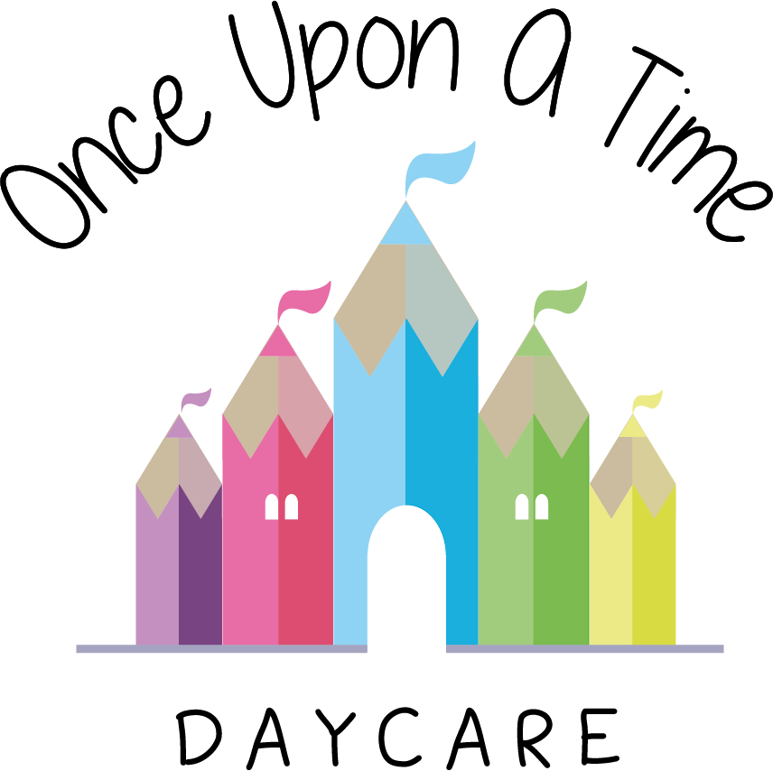

Special Consideration for Employees
2b. Special Consideration for Employees

At Once Upon A Time Daycare we recognise that certain employees such as young persons, new and expectant mothers and persons with a disability may require special consideration.

Legal requirements
The nursery follows the legal requirements set out in The Management of Health and Safety at Work Regulations 1992 and the Equality Act 2010. Our Health and Safety Policy has regard to any employees requiring special consideration at the commencement of employment and during the course of it. The following procedure is followed.

Procedure
The nursery manager:
- Assesses any employee requiring special consideration in conjunction with the individual on induction to the nursery or when their condition or disablement comes to light
- Carries out any risks assessments relating to the occupation of such workers
- Agrees with the worker any necessary special measures such as training and supervision, arrangements, modifications and medical surveillance
- Carries out further assessments and reviews at least annually, or if and when any changes to the special circumstances or environment occur.

Disabilities
If you are disabled or become disabled, we encourage you to tell us about your condition so that we can consider what reasonable adjustments or support may be appropriate.

Part-time and fixed-term work
Part-time and fixed-term employees should be treated the same as comparable full-time or permanent employees and enjoy no less favourable terms and conditions (on a pro-rata basis where appropriate), unless different treatment is justified.

This policy was adopted on | Signed on behalf of the nursery | Date for review
1/6/18 | Rebecca Street (Manager) | 1/6/19
Date Reviewed 1/5//19 | Rebecca Street (Manger) | 1/5/20
Date Reviewed 1/3/20 | Rebecca Street (Manager) | 1/3/21
Date Reviewed 1/3/21 | Rebecca Street (Manager) | 1/3/22

