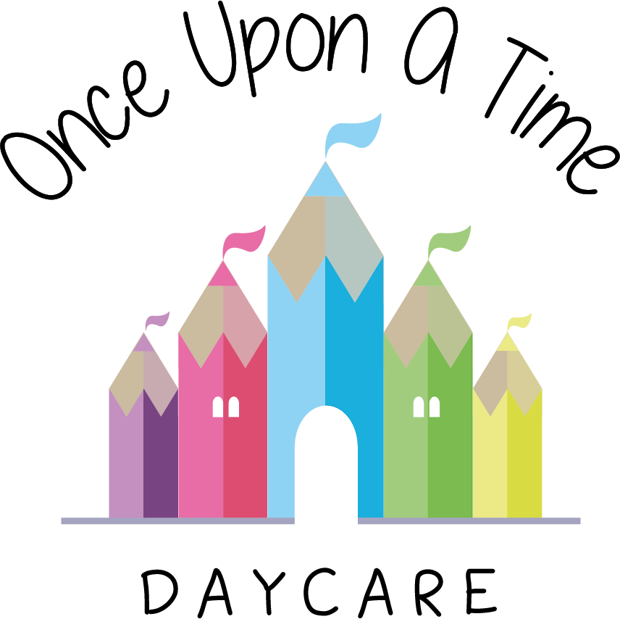

Adverse Weather
23. Adverse Weather

EYFS: 3.58

At Once Upon A Time Daycare we have an adverse weather policy in place to ensure our nursery is prepared for all weather conditions that might affect the running of the nursery such as floods, snow and heat waves.

If any of these incidents impact on the ability of the nursery to open or operate, we will contact parents via phone/email

We will not take children outdoors where we judge that weather conditions make it unsafe to do so.

Flood
In the case of a flood we will follow our critical incident procedure to enable all children and staff to be safe and continuity of care to be planned for.

Snow or other severe weather
If high snowfall, or another severe weather condition such as dense fog, is threatened during a nursery day then the manager will take the decision as to whether to close the nursery. This decision will take into account the safety of the children, their parents and the staff team. In the event of a planned closure during the nursery day, we will contact all parents to arrange for collection of their child.

In the event of staff shortages due to snow or other severe weather we will contact all available off duty staff and/or agency staff and group the children differently until they are able to arrive. If we are unable to maintain statutory ratio requirements after all avenues are explored we will contact Ofsted to inform them of this issue, recording all details in our incident file. If we feel the safety, health or welfare of the children is compromised then we will take the decision to close the nursery.

Heat wave
Please refer to our sun care policy.

This policy was adopted on | Signed on behalf of the nursery | Date for review
1/6/18 | Rebecca Street (Manager) | 1/6/19
Date Reviewed 1/5//19 | Rebecca Street (Manger) | 1/5/20
Date Reviewed 1/3/20 | Rebecca Street (Manager) | 1/3/21
Date Reviewed 1/3/21 | Rebecca Street (Manager) | 1/3/22

