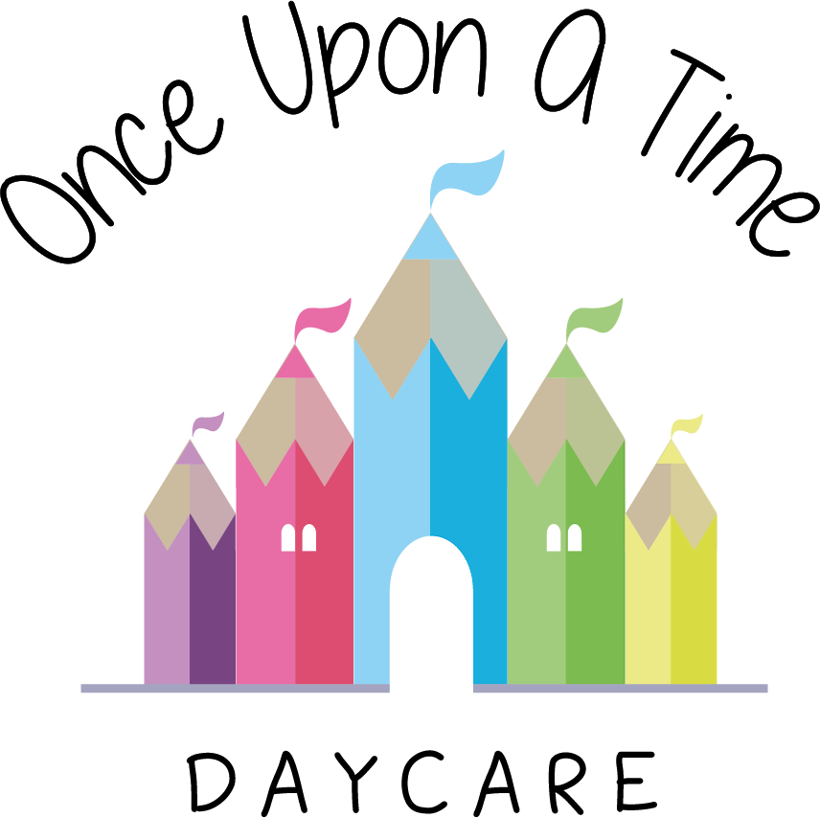

Alcohol and Substance Misuse
20. Alcohol and Substance Misuse

EYFS: 3.19

At Once Upon A Time Daycare we are committed to providing a safe environment that helps to ensure the welfare of the children in our care. This includes making sure that children are not exposed to adults who may be under the influence of alcohol or other substances that may affect their ability to care for children.

Alcohol
Under the Health and Safety at Work Act 1974, companies have a legal requirement to provide a safe working environment for all of their employees.

Anyone who arrives at the nursery clearly under the influence of alcohol will be asked to leave. If they are a member of staff, the nursery will investigate the matter and will initiate the disciplinary process as a result of which action may be taken, including dismissal. If they are a parent the nursery will judge if the parent is suitable to care for the child. The nursery may call the second contact on the child’s registration form to collect them. If a child is thought to be at risk the nursery will follow the safeguarding children/child protection procedure and the police/children’s social services may be called.

If anyone arrives at the nursery in a car under the influence of alcohol the police will be contacted.

Staff, students, parents, carers, visitors, contractors etc. are asked not to bring alcohol on to the nursery premises.

Substance misuse
Anyone who arrives at the nursery under the influence of illegal drugs, or any other substance including medication, that affects their ability to care for children, will be asked to leave the premises immediately. If they are a member of staff, an investigation will follow which may lead to consideration of disciplinary action, as a result of which dismissal could follow. If they are a parent the nursery will judge if the parent is suitable to care for the child. The nursery may call the second contact on the child’s registration form to collect them. If a child is thought to be at risk the nursery will follow the safeguarding children/child protection procedure and the police may be called.

The nursery will contact the police if anyone (including staff, students, volunteers, contractors and visitors) is suspected of being in possession of illegal drugs or if they are driving or may drive when under the influence of illegal drugs.
If they are a member of staff serious disciplinary procedures will be followed.

If a member of staff is taking prescriptive medication that may affect their ability to work, they must inform the nursery manager as soon as possible to arrange for a risk assessment to take place.

Safeguarding/child protection
If a parent or carer is clearly over the alcohol limit, or under the influence of illegal drugs and it is believed the child is at risk we will follow our safeguarding/child protection procedures, contact social services and the police.

Staff will do their utmost to prevent a child from travelling in a vehicle driven by them and if necessary the police will be called.

Where an illegal act is suspected to have taken place, the police will be called.

This policy was adopted on | Signed on behalf of the nursery | Date for review
1/6/18 | Rebecca Street (Manager) | 1/6/19
Date Reviewed 1/5//19 | Rebecca Street (Manger) | 1/5/20
Date Reviewed 1/3/20 | Rebecca Street (Manager) | 1/3/21
Date Reviewed 1/3/21 | Rebecca Street (Manager) | 1/3/22

