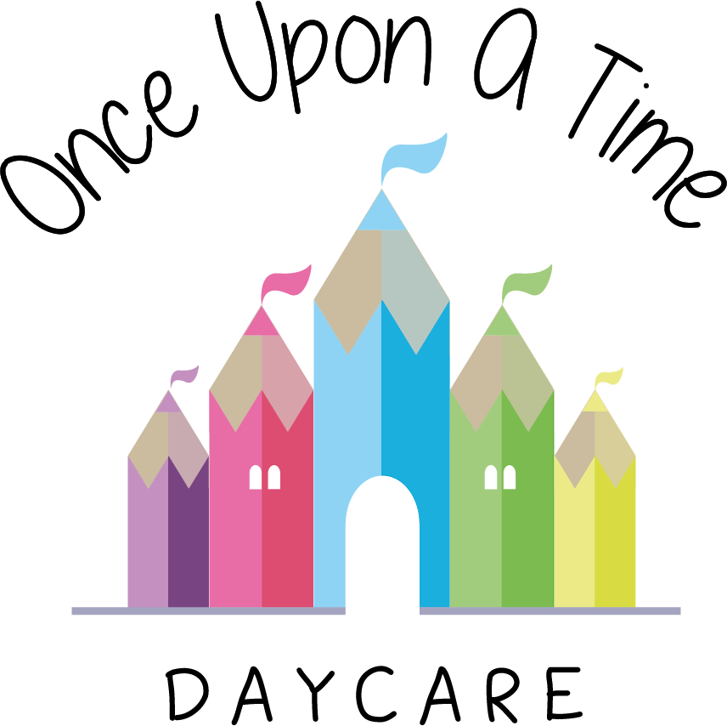

Whistleblowing
1d. Whistleblowing

EYFS: 3.4 – 3.18 and 3.22

At Once Upon A Time Daycare we expect all our colleagues, both internal and external, to be professional at all times and hold the welfare and safety of every child as their paramount objective.

We recognise that there may be occasions where this may not happen and we have in place a procedure for staff to disclose any information that suggests children’s welfare and safety may be at risk.

We expect all team members to talk through any concerns they may have with their line manager at the earliest opportunity to enable any problems to be resolved as soon as they arise.

Legal framework
The Public Interest Disclosure Act 1998, commonly referred to as the ‘Whistleblowing Act’, amended the Employment Rights Act 1996 to provide protection for employees who raise legitimate concerns about specified matters. These are called ‘qualifying disclosures’. On 25 June 2013, there were some legal changes to what constitutes a qualifying disclosure.

A qualifying disclosure is one made in the public interest by an employee who has a reasonable belief that:
- A criminal offence
- A miscarriage of justice
- An act creating risk to health and safety
- An act causing damage to the environment
- A breach of any other legal obligation or
- Concealment of any of the above
- Any other unethical conduct
- An act that may be deemed as radicalised or a threat to national security
Is being, has been, or is likely to be, committed.

Qualifying disclosures made before 25 June 2013 must have been made ‘in good faith’ but when disclosed, did not necessarily have to have been made ‘in the public interest.’

Disclosures made after 25 June 2013 do not have to be made ‘in good faith’; however, they must be made in the public interest. This is essential when assessing a disclosure made by an individual.

The Public Interest Disclosure Act has the following rules for making a protected disclosure:
- You must believe it to be substantially true
- You must not act maliciously or make false allegations
- You must not seek any personal gain.

It is not necessary for the employee to have proof that such an act is being, has been, or is likely to be, committed; a reasonable belief is sufficient.

Disclosure of information
If, in the course of your employment, you become aware of information which you reasonably believe indicates that a child is/may be or is likely to be in risk of danger and/or one or more of the following may be happening, you MUST use the nursery’s disclosure procedure set out below:
- That a criminal offence has been committed or is being committed or is likely to be committed
- That a person has failed, is failing or is likely to fail to comply with any legal obligation to which they are subject (e.g. EYFS, Equalities Act 2010)
- That a miscarriage of justice has occurred, is occurring, or is likely to occur
- That the health or safety of any individual has been, is being, or is likely to be endangered
- That the environment, has been, is being, or is likely to be damaged
- That information tending to show any of the above, has been, is being, or is likely to be deliberately concealed.

Disclosure procedure
- If this information relates to child protection/safeguarding then the nursery *child protection/*safeguarding children policy should be followed, with particular reference to the staff and volunteering section
- Where you reasonably believe one or more of the above circumstances listed above has occurred, you should promptly disclose this to your manager so that any appropriate action can be taken. If it is inappropriate to make such a disclosure to your manager (i.e. because it relates to your manager) you should speak to Cherise Hatfield 07999111666
- Employees will suffer no detriment of any sort for making such a disclosure in accordance with this procedure. For further guidance in the use of the disclosure procedure, employees should speak in confidence to the *nursery manager/*owner
- Any disclosure or concerns raised will be treated seriously and will be dealt with in a consistent and confidential manner and will be followed through in a detailed and thorough manner
- Any employee who is involved in victimising employees who make a disclosure, takes any action to deter employees from disclosing information or makes malicious allegations in bad faith will be subject to potential disciplinary action which may result in dismissal
- Failure to report serious matters can also be investigated and potentially lead to disciplinary action which may result in dismissal
- Any management employee who inappropriately deals with a whistleblowing issue (e.g. failing to react appropriately by not taking action in a timely manner or disclosing confidential information) may be deemed to have engaged in gross misconduct which could lead to dismissal
- We give all of our staff the telephone numbers of the Local Authority Designated Officer (LADO), the local authority children’s social care team, the Local Safeguarding Children Board (LSCB) and Ofsted so all staff may contact them if they cannot talk to anyone internally about the issues/concerns observed.

This policy was adopted on | Signed on behalf of the nursery | Date for review
1/6/18 | Rebecca Street (Manager) | 1/6/19
Date Reviewed 1/5//19 | Rebecca Street (Manger) | 1/5/20
Date Reviewed 1/3/20 | Rebecca Street (Manager) | 1/3/21
Date Reviewed 1/3/21 | Rebecca Street (Manager) | 1/3/22

