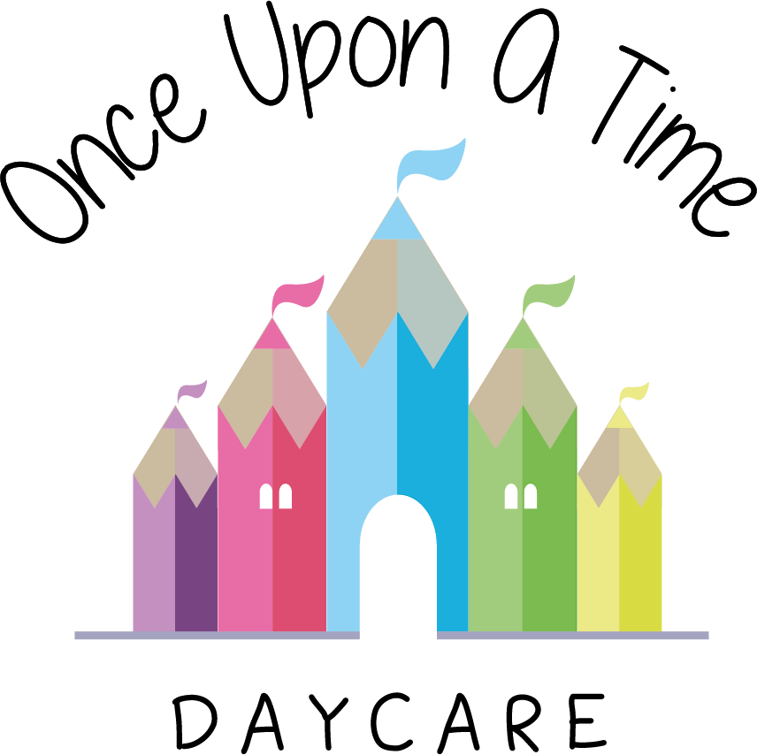

Visits and Outings
16. Visits and Outings

EYFS: 3.65, 3.66

At Once Upon A Time Daycare we offer children a range of local outings including walks and visits off the premises. We believe that planned outings and visits complement and enhance the learning opportunities inside the nursery environment and extend children’s experiences. We always seek parents’ permission for children to be included in such outings.

Procedures
Visits and outings are carefully planned using the following guidelines, whatever the length or destination of the visit:
- A pre-visit checklist, full risk assessment and outings plan will always be carried out by a senior member of staff before the outing to assess the risks or hazards which may arise for the children, and identify steps to be taken to remove, minimise and manage those risks and hazards. We will endeavour to visit the venue prior to the visit. This will ensure that the chosen venue is appropriate for the age, stage and development of the children
- Written permission will always be obtained from parents before taking children on trips
- We provide appropriate staffing levels for outings dependent on an assessment of the safety and the individual needs of the children.
- At least one member of staff will hold a valid and current paediatric first aid certificate and this will be increased where risk assessment of proposed activity deems it necessary
- A fully stocked first aid box will always be taken on all outings along with any special medication or equipment required
- A completed trip register together with all parent and staff contact numbers will be taken on all outings
- Regular headcounts will be carried out throughout the outing. Timings of headcounts will be discussed in full with the nursery manager prior to the outing
- All staff will be easily recognisable by other members of the group; they will wear the nursery uniform and high visibility vests/jackets
- Children will be easily identified by staff when on a trip by use of high visibility jackets for all children attending the trip. The nursery name, number and mobile number will be displayed
- A fully charged mobile phone will be taken as a means of emergency contact
- In the event of an accident, staff will assess the situation. If required, the group will return to nursery immediately and parents will be contacted to collect their child. In the event of a serious accident an ambulance will be called at the scene, as well as parents being contacted. One member of staff will accompany the child to the hospital, and the rest of the group will return to the nursery.

Risk assessment/outings plan
The full risk assessment and outing plan will be displayed for parents to see before giving consent. This plan will include details of:
- The name of the designated person in charge - the outing leader
- The name of the place where the visit will take place
- The estimated time of departure and arrival
- The number of children, age range of children, the ratio of staff to children, children’s individual needs and the group size
- The equipment needed for the trip, i.e. first aid kit, mobile phone, coats, safety reins, pushchairs, rucksack, packed lunch etc.
- Staff contact numbers
- Method of transportation and travel arrangements (including the route)
- Financial arrangements
- Emergency procedures
- The name of the designated first aider and the first aid provision
- Links to the child’s learning and development needs.

Use of vehicles for outings
- All staff members shall inform parents in advance of any visits or outings involving the transportation of children away from the nursery
- The arrangements for transporting children will always be carefully planned and where necessary additional people will be recruited to ensure the safety of the children. This is particularly important where children with disabilities are concerned
- All vehicles used in transporting children are properly licensed, inspected and maintained
- Regular checks are made to the nursery vehicle e.g. tyres, lights etc. and a logbook of maintenance, repairs and services is maintained
- The nursery vehicle is to be kept in proper working order, is fully insured for business use and is protected by comprehensive breakdown cover
- Drivers of vehicles are adequately insured
- All vehicles used are fitted to the supplier’s instructions with sufficient numbers of safety restraints appropriate to the age/weight of the children carried in the vehicle. Any mini buses/coaches are fitted with 3-point seat belts
- When we use a mini bus, we check that the driver is over 21 years of age and holds a Passenger Carrying Vehicle (PCV) driving licence. This entitles the driver to transport up to 16 passengers
- When children are being transported, we maintain ratios.

When planning a trip or outing using vehicles, records of vehicles and drivers including licenses, MOT certificates and business use insurance are checked. If a vehicle is used for outings the following procedures will be followed:
- Ensure seat belts, child seats and booster seats are used
- Ensure the maximum seating is not exceeded
- All children will be accompanied by a registered member of staff
- No child will be left in a vehicle unattended
- Extra care will be taken when getting into or out of a vehicle
- The vehicle will be equipped with a fire extinguisher and emergency kit containing warning triangle, torch, blankets, wheel changing equipment etc.

Lost children
In the event of a child being lost, the Lost Child Procedure will be followed. Any incidents or accidents will be recorded in writing and Ofsted will be contacted and informed of any incidents.

There may be opportunities for parents to assist on outings. The manager will speak to parents prior to the visit regarding health and safety and code of conduct.

In the event of an emergency (including a terrorist attack)
In the event of an emergency whilst out on a visit, we encourage staff to find a safe haven and remain there until the danger passes. Each outing will have a detailed risk assessment, which covers all these risks and is planned ahead.

This could cover other issues such as extreme weather, emergency (such as an ill or injured child) etc.

Also think about how to contact parents to let them know everything is ok.

Further information can be found at:
http://www.npcc.police.uk/NPCCBusinessAreas/WeaponAttacksStaySafe.aspx

This policy was adopted on | Signed on behalf of the nursery | Date for review
1/6/18 | Rebecca Street (Manager) | 1/6/19
Date Reviewed 1/5//19 | Rebecca Street (Manger) | 1/5/20
Date Reviewed 1/3/20 | Rebecca Street (Manager) | 1/3/21
Date Reviewed 1/3/21 | Rebecca Street (Manager) | 1/3/22
*Due to the current Covid-19 pandemic and in line with our Covid-19 risk assessments, outings have been suspended to ensure we are adhering to the up to date government guidance. This will be re-visited when the guidance changes on lockdown rules and social distancing.

