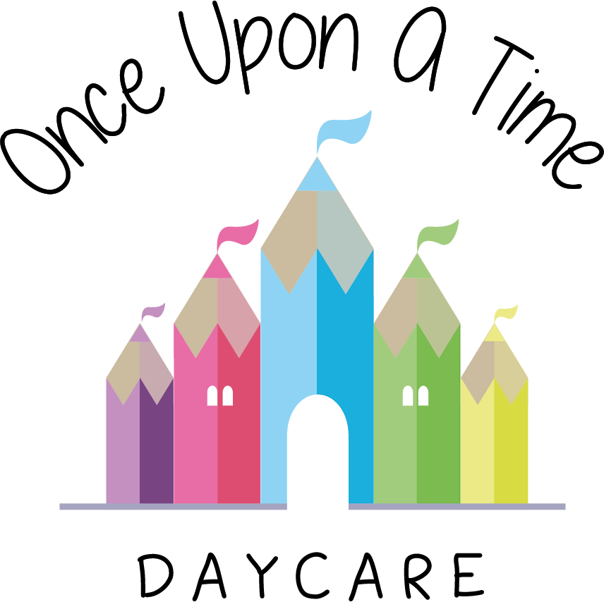

Sustainable Practice
15. Sustainable Practice

At Once Upon A Time Daycare nursery we value our environment. In order to keep our earth safe and healthy for our children we closely monitor the management of our waste and its disposal in accordance with local authority requirements.

Staff are made aware of the need to minimise energy waste and the nursery uses appropriate measures to save energy including:
- Energy saving light bulbs
- Turning off lights when not in use
- Not leaving any equipment on standby
- Unplugging all equipment at the end of its use/the day
- Energy saving wash cycles on the washing machine.

The nursery recycles paper waste at paper banks and ensures that where possible other sources of waste are recycled to reduce the effect on the environment.

We assess our nursery’s impact on the environment on a regular basis and put procedures in place to counteract this impact.

Where age/stage appropriate, we help children to understand the importance of sustainable lifestyles including how to be healthy as well as recycling, energy saving etc.

In order to encourage children not to waste food, or to play with food at mealtimes, we discourage the use of food as a play material; instead we encourage activities which involve preparing and tasting different types of food.

This policy is reviewed annually and is carefully considered in the best interests of the children, nursery and the environment.

This policy was adopted on | Signed on behalf of the nursery | Date for review
1/6/18 | Rebecca Street (Manager) | 1/6/19
Date Reviewed 1/5//19 | Rebecca Street (Manger) | 1/5/20
Date Reviewed 1/3/20 | Rebecca Street (Manager) | 1/3/21
Date Reviewed 1/3/21 | Rebecca Street (Manager) | 1/3/22

