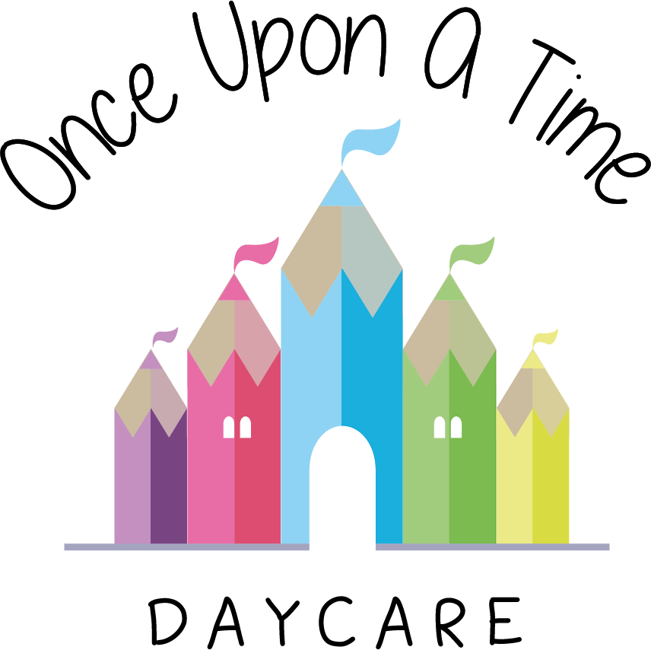

Healthy Workplace
13. Healthy Workplace

EYFS 3.44, 3.47, 3.48

At Once Upon A Time Daycare we are committed to providing a workplace which supports and encourages a healthy staff team through staff training, health and safety awareness and supervisions.

Dress code
Staff must follow our dress code at all times. The dress code is detailed in [staff behaviour policy].

Staff breaks
It is the responsibility of the nursery manager to ensure that all staff working five hours or more take a break of 20 minutes, 30 minutes or 60 minutes dependant on hours worked and ensuring that ratios are maintained.

Staff under 18 require a break of 30 minutes in circumstances where they work 4.5 hours a day. All breaks should be taken away from an employee’s normal work area (where this is applicable).

Personal hygiene
Staff must follow the personal hygiene code at all times and encourage children to adopt the same good personal hygiene code themselves.

All hands must be washed before handling food, after using the toilet or toileting children, after playing outside, wiping noses, messy play activities and after contact with animals.

After noses have been wiped the tissue must be disposed of hygienically and hands should be washed.

Cleaning
The nursery is committed to providing a safe, happy and healthy environment for children to play, grow and learn. Cleanliness is an essential element of this practice. The nursery will be cleaned daily and regular checks will be made to the bathrooms. These will be cleaned at least daily (more if necessary i.e. at lunch time). The nappy changing facility will be cleaned after every use and potties will be cleaned out after every use. Any mess caused throughout the day will be cleaned up as necessary to ensure that a hygienic environment is provided for the children in our care.

Kitchen
Staff are made aware of the basic food hygiene standards through appropriate training and this is reviewed every three years.
- Fridges to be cleaned out weekly
- Microwave to be cleaned after every use
- Oven to be cleaned out regularly and recorded
- Freezers to be cleaned out every three months and recorded
- All cupboards to be cleaned out monthly
- Fridge and freezer temperatures must be recorded first thing in the morning by the manager/cook and last thing at night
- All food to be covered at all times in and out of the fridge and dated to show when each product was opened
- Care must be taken to ensure that food is correctly stored in fridges
- When re-heating food, it should be over 75°C, checked with the probe thermometer and recorded, then cooled down before serving. Food prepared on the premises must be checked with the probe thermometer before serving
- Food served but not used immediately should be appropriately covered and placed in the fridge/freezer within 60 minutes. If this is not followed, food should be discarded immediately
- All opened packets to be dated when opened and placed in an airtight container e.g. baby food, raisins, cereal etc.
- Blended food should be placed in suitable airtight containers, named and dated
- Surfaces to be cleaned with anti-bacterial spray
- Only appropriate coloured kitchen cloths to be used (please follow the chart on the wall). These must be washed daily on a hot wash
- Windows protected by fly guards to be opened as often as possible along with the vents
- All plugs to be pulled out of their sockets at the end of each day and switches switched off where practicable (with the exception of the fridge and freezer)
- Children must NOT enter the kitchen except for supervised cooking activities
- Doors/gates to the kitchen to be kept closed/locked at all times.

Baby room
- Bottles of formula milk will only be made up as and when the child needs them. These should be cooled to body temperature (37°C) and tested with a sterilised thermometer to ensure they are an appropriate temperature for the child to drink safely
- Following the Department of Health guidelines, we will only use recently boiled water to make formula bottles (left for no longer than 30 minutes to cool). We will not use cooled boiled water and reheat
- Bottles and teats will be thoroughly cleaned with hot soapy water and sterilised after use (they will not be washed in the dishwasher)
- Content of bottles will be disposed of after two hours
- A designated area is available for mothers who wish to breastfeed their babies or who wish to express milk
- Labelled mother’s breast milk will be stored in the fridge
- If dummies are used they will be cleaned and sterilised. This also applies to dummies which have been dropped
- All dummies will be stored in separate labelled containers to ensure no cross-contamination occurs
- Sterilisers will be washed out daily.

Nursery
- Staff must be aware of general hygiene in the nursery and ensure that high standards are kept at all times
- Regular toy washing rotas must be established in all rooms and recorded. Toys should be washed with sanitising fluid
- Floors should be cleaned during the day when necessary. Vacuum cleaner bags (where used) should be changed frequently
- Staff are requested to use the appropriate coloured mop for the task or area (see chart on wall) and mop heads should be washed in a separate wash at least weekly
- Face cloths should be washed on a hot wash after every use and not shared between children
- Low/high chairs must be cleaned thoroughly after every use. Straps and reins must be washed weekly or as required
- Every child should have its own cot sheet which should be washed at the end of every week or whenever necessary
- All surfaces should be kept clean and clutter free
- Children must always be reminded to wash their hands after using the bathroom and before meals. Staff should always encourage good hygiene standards, for example, not eating food that has fallen on the floor
- Children should learn about good hygiene routines and why they need to wash their hands, wipe their noses and cover their mouths when coughing.

Staff rooms
- It is the responsibility of every member of staff to ensure that their staff room is kept clean and tidy
- Fridges must be cleaned out weekly
- Microwave to be cleaned after every use
- Surfaces to be wiped down daily
- All implements used for lunch or break to be washed and tidied away.

This policy was adopted on | Signed on behalf of the nursery | Date for review
1/6/18 | Rebecca Street (Manager) | 1/6/19
Date Reviewed 1/5//19 | Rebecca Street (Manger) | 1/5/20
Date Reviewed 1/3/20 | Rebecca Street (Manager) | 1/3/21
Date Reviewed 1/3/21 | Rebecca Street (Manager) | 1/3/22

Further legal advice regarding this can be found at https://www.citation.co.uk/insights/dress-code-policy-and discrimination?utm_source=NDNA&utm_campaign=Jan17&utm_medium=sponsored%20links

